**XIII INTERNATIONAL MEETING OF THE ANDEAN NETWORK OF TRADITIONAL KNOWLEDGE AND PRACTICES**

**(Tiquipaya, Cochabamba, BOLIVIA, AUGUST 4-6, 2025)**

**"KNOW-HOW OF ANDEAN INDIGENOUS PEOPLES IN PASTORALISM, CRAFTS, AND MEDICINAL PLANTS"**

Around 100 pastoralists from 06 countries in the Andean region from Argentina, Chile, Ecuador, Colombia, Peru and Bolivia met in Tiquipaya, Quillacollo province, Cochabamba department, Bolivia, to discuss the Know-How of Andean Indigenous Peoples in Pastoralism, Crafts and Medicinal Plants from the pastoralists themselves: their organization, their ways of raising animals, mainly of South American camelids, as well as to discuss and analyze the effects of climate change on their systems, territories and livelihoods, in order to promote sustainable management of their livestock and grazing lands, to raise awareness of the potential of medicinal plants and the role of women artisans, as well as to make visible and promote international support among countries in the region and to build regional agendas for future meetings and gatherings. In this regard, the 13th Meeting of the Andean Network of Traditional Knowledge and Practices was held in Tiquipaya, Bolivia, as part of the preparations for the celebration of the International Year of Rangelands and Pastoralists (IYRP) 2026.

***Context***

In the high Andes mountains, between 3,500 and 4,800 meters above sea level, there is a population estimated at more than 200,000 families (FAO 2024), composed primarily of indigenous communities who live off the breeding/herding of South American camelids, such as alpacas and llamas, wild species like the vicuña, and introduced species such as sheep and cattle. These populations possess knowledge, skills, and resources with high potential, such as these South American camelids, which are essential for the economy and food security.

As in most pastoralist societies around the world, the approach is holistic and comprehensive. The fragmented view of ecosystems is contrary to the Andean worldview; in this sense, the Andean Network of Traditional Knowledge and Practices incorporates a variety of activities that pastoralists carry out. This is why it is important to discuss pastoralism in an integrated way, including the practices that accompany it, such as traditional medicine and crafts as a way of life.

This year's theme is pastoralism, and participants are pastoralists who practice this livelihood. To ensure participation, each node coordinator from each country is responsible for contacting and selecting Andean communities dedicated to the herding of South American camelids, medicinal plants, ancestral medicine, and high Andean artisans. This will promote their participation and support them in presenting their testimonies and stories related to the breeding, management, community organization, management and use of medicinal plants, and the use of camelid fiber, primarily in the artisanal field.

The hosts were the Tiquipaya Municipal Autonomous Government and the 13 de Agosto Watershed Management Organization (OGC 13 de Agosto), made up of five rural communities. The meeting was organized by REDAR Perú and the Andean Network of Traditional Knowledge and Practices, with financial support from various local entities and the support of the IYRP Global Alliance in the thematic organization and with the main presentation on pastoralism and the Andean region.

***Event activities***

***Day 1***

* Event Opening
* PROTOCOL CEREMONY - Words of Honor
* Traditional Bolivian Dances

***Day 2***

* Presentation: Pastoralism in the World and the Situation in the Andean Region, IYRP Global Alliance

Morning: Panels based on testimonies from event participants

* Panel 1: Pastoralist practices related to alpacas, llamas, and vicuñas: management, reproduction, health and rituals
* Panel 2: Knowledge about the use, management, and sustainability of high Andean rangelands, grasslands and/or wetlands: importance and challenges

Afternoon: Panels based on testimonies from event participants

* Panel 3: The Role of pastoralists in the Breeding System and Adding Value to Fiber and By-Products from South American Camelids
* Panel 4: Use, Conservation, and Values from Medicinal Plants

***Day 3***

Morning: Participation in the city parade celebrating the 200th anniversary of the independence of the Plurinational State of Bolivia

Afternoon: Group work: Thematic division to share experiences and build participatory conclusions

* WORKING GROUP 1: Pastoralism and herd management. Traditional knowledge and ancestral practices in camelid management, pastoralist lifestyles
* WORKING GROUP 2: Knowledge about rangeland management and environmental sustainability
* WORKING GROUP 3: High Andean artisan women. Processing and marketing of pastoral products
* WORKING GROUP 4: Medicinal plants and traditional healers

***Day 4: Field Trip***

* Visit to the llama and rangeland management experiences in the Totora-Tiquipaya Community
* Visit to the local school, ceremony and lunch
* Visit to the traditional medicine management experiences in the Cruzani-Tiquipaya Community and a native tree nursery for reforestation.
* Delivery of the event's artistic painting in the Cruzani Community. Inauguration of the mural alluding to pastoralism and Mother Earth.

***Results achieved***

• Build common proposals and gather agreements based on the sharing of participants' experiences that will serve to build agendas and proposals from the Andean region

• Establish a working horizon regarding the participation of Andean Knowledge Network members in IYRP 2026 activities

**Photo Panel**

All images are located in the following folder: <https://drive.google.com/drive/folders/1sptx4NqDyU09YTOLLeS7ttLUuI3JjzoB?usp=drive_link>

Banner for the 13th International Meeting of the Andean Network of Knowledge and Actions, featuring the six participating countries and logos of participating institutions. The design alludes to Mother Earth and its integration with food, medicine, pastoralism, and the role of women

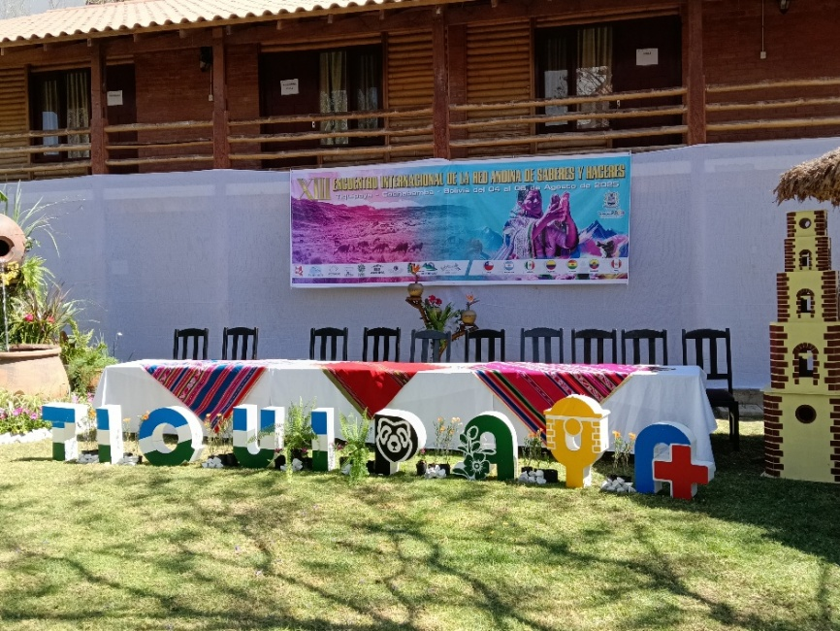

Inaugural honor head table

Presentation of "La Diablada." Traditional Bolivian dances

Inaugural head table: Víctor Inocencio (Bolivia), Wilson Paiz (Bolivia) Lic. Jhovana Godoy (Bolivia), Mrs. Gregoria Vargas (Bolivia), Dr. Juan Pahuasi Argote (Mayor of Tiquipaya Bolivia), Sonia Salas Domínguez (Redar-Peru), Mr. Roy Antonio Vilcayauri Segura (Mayor of Tupicocha, Peru), Mrs. Maritza Mayorca (Peru node), Gualberto Ticona (Bolivia Node), Enrique Michaud (IYRP Global Alliance, Peru)

Presentation: Pastoralism in the World and the Situation in the Andean Region. Enrique Michaud, Co-Chair, IYRP Global Alliance

Presentation of the event's methodology and the first panel discussion by the meeting participants

Panel 1: Pastoralism and Practices Associated with Alpacas, Llamas, and Vicuñas: management, reproduction, health, rituals

Nelson Galindo Sánchez Porras from Pasco, central Andes, Peru, shares his work on traditional knowledge related to ancestral pastoral practices involving alpacas and llamas.

Presentation performed by Victoria Alcasihuincha, an alpaca herder from Tolconi, in Arequipa, southern Peruvian Andes, using audiovisuals: showing the movement of alpaca herds during rainy season

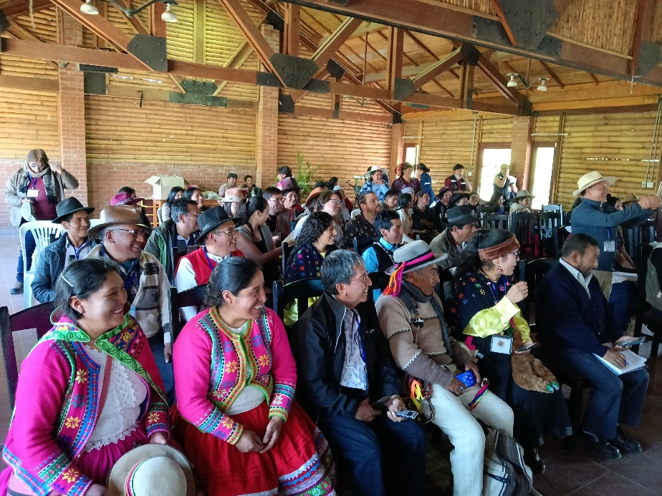

Participants of the Andean Network Meeting, "Know-how of the Andean Indigenous Peoples, in Pastoralism, Crafts and Medicinal Plants"

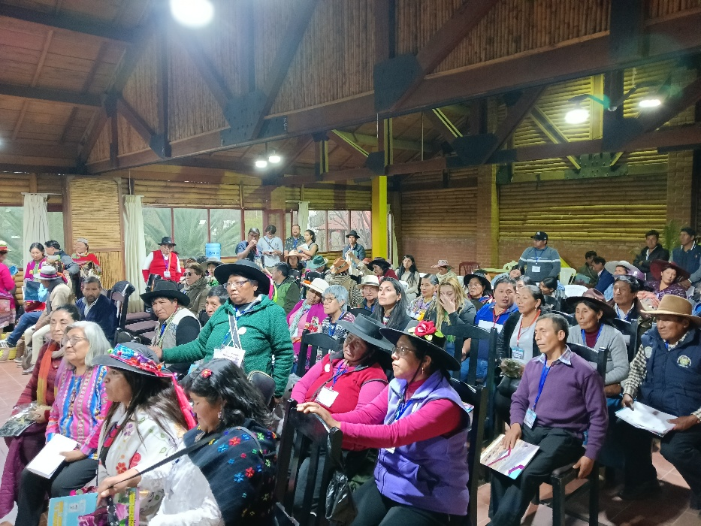

Participants of the Andean Network Meeting, "Know-how of the Andean Indigenous Peoples, in Pastoralism, Crafts and Medicinal Plants"

Group photo of the participants in Panel 03 on women artisans and added value. Participants belong to delegations from Argentina, Ecuador, Peru, and Bolivia.

Presentation from Junín, Andes of central Peru Panel 04, Medicinal plants, professor Jorge and his student showing the local use of some plants for animal health

Panel 04 on medicinal plants. Presentation by Cecilia Sandon from Chile, an expert in the knowledge and use of plants in reproductive and postpartum management in women.

Panel 04 Plants and Medicines, with a very active participation of women's groups with traditional knowledge regarding biodiversity

Presentation performed by Mr. Toribio Condo from Arequipa, southern Andes of Peru, during panel 04: Use of medicinal plants, using audiovisual aids, and identifying local plants of his community with their respective scientific name, proving an integration of traditional and modern knowledge.

International delegations with their traditional dressing and national flags in the parade commemorating the 200th anniversary of the independence of the Plurinational State of Bolivia.

Presentation of the conclusions of the group work tables, and discussion of the conclusions for drafting the document of agreements and commitments of the meeting

Demonstration of the use of llamas for caravans and how weight is distributed and tied for llama caravans. The demonstration was conducted by llama herders from Pasco, in the central Andes of Peru, using llamas from Bolivia, proving the intercultural relationship and close ties between traditional Andean practices and breeding systems.

Group organizing the meeting with the llama herd used for the handling demonstration conducted during the field visit

Demonstration of medicinal plants during the field visit, shows the ongoing exchange of knowledge among participants

Traditional dance performance by children from the host community's school, Sub Central Totora - Tiquipaya

Group organizing the meeting with local authorities during the celebratory lunch at the local host community school

The organization's group in the artistic painting of the event: Enrique Michaud co-chair of the IYRP Global Alliance, Luz Andrea Gonzales muralist from Colombia, Dr. Sonia Salas director of REDAR Peru, William from the Colombia Node, Gualberto Ticona from the Bolivia node and Benjamín Vargas from Bolivia