An Approach towards Formalizing Commons in Revenue Records in Jaisalmer district of Rajasthan
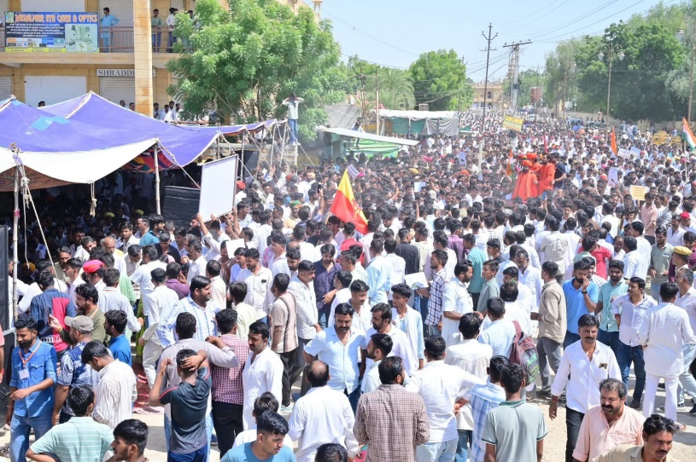
The state of Rajasthan, especially western part faces arid climate where rainfall is low and erratic. Droughts are recurrent phenomena and crop production is uncertain. Therefore livestock rearing has evolved as an adaptation strategy to cope with climate extremities in the region. Livestock rearing is an important source of livelihood for a large number of pastoralist and agri-pastoralist communities. The sustainability of this extensive pastoralism is dependent on natural grazing in community property resources (CPRs) found abundantly in the region. CPRs in western Rajasthan include Gauchars (grazing lands reserved exclusively for livestock grazing), Orans (sacred groves, which are rich in biodiversity and usually include a water body), Beers (grasslands for hay making), Agor (water catchment areas), Jorh or Tobas (village ponds), Ranns (saline depressions) and Khadins (crop cultivation under conserved moisture/ run-off farming). Traditionally, these commons were managed by the local communities. However, CPRs are facing severe degradation and encroachment since last few decades. Many of these commons are registered as “waste lands” or “uncultivable waste lands” in the revenue department records rendering these commons most vulnerable to diversion for non-agriculture development projects such as wind mill , solar power and cement factories. These commons are allotted by state government to development projects further shrinking the area under commons. Transition from subsistence to commercial agriculture owing to increase in irrigation, access to better roads and markets has brought economic transition in the region.
However, in the recent past, pastoral and agri-pastoral communities have realized the importance of these commons for their livelihood, regional economy and biodiversity. Oran Conservation Committee, a group of pastoralists, farmers, environmental activists and citizens in Jaisalmer district are organizing protests for scientific conservation and management of these commons. One of their important demands is to register the Orans and Gauchars as such in the revenue department records. The team has undertaken Padayatra (procession on foot) in all villages of the district since last few years raising awareness among the pastoralists, farmers and the villagers. Recently, they held a protest in front of the collectorate office in Jaisalmer city in the form of an indefinite hunger strike demanding that Orans and Gauchars be formally recorded in revenue records. The protests have received wide support from public and people from all walks of life. The public representatives such as MLAs in the district too have supported the protest to the Oran team. A day before Deeepawali, district administration held a meeting with Oran team involving local MLAs. The Oran team was assured that the commons including public properties will be surveyed and measures will be taken for their protection and conservation. The representations received from different villages for registration of Orans will be forwarded to the state government. It was decided that the survey will be undertaken on priority basis in those areas which are allotted for solar and cement factories. The Gram Panchayats and the public representatives will be involved in the entire survey process. With this, the Oran team has withdrawn their 34 days long protest. Mr. Sumer Singh Sanwta and Bhopal Singh from Oran team informed that both MLAs and district administration have assured that Orans will be registered in the revenue department records in three months time .
The district administration has initiated the process of recording and surveying the commons in the district in official revenue records. The survey work is being undertaken in mission mode with the joint survey teams consisting of officials from revenue, irrigation and other departments. It is reported that administration has so far demarcated around 70,000 bighas of land across 47 villages and submitted the proposal to the state government for approval for recording in revenue department records. The protests being held in Jaislamer district since last few years for registration of Orans in revenue department records and the action taken by the Government and administration is already having a rippling effect in the entire Rajasthan.
Compilation : P. Vivekanandan, SEVA/ IYRP South Asia Date : 30-10-2025

