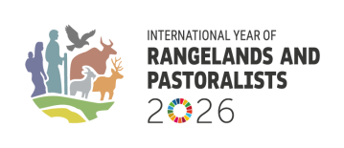
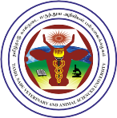
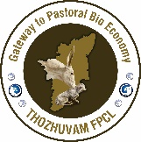
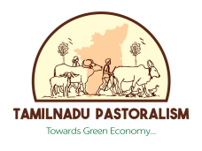

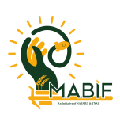

International Convention on Pastoral Bio-Economy and Decarbonisation
Theme: Pastoral Bio-Economy for Low-Carbon Future
05 December 2025 , Madras Veterinary College - Chennai, Tamil Nadu

The International Convention on Pastoral Bio-Economy and Decarbonisation, held on 05 December 2025 at Madras Veterinary College campus jointly organised by Thozhuvam Farmer Producer Company Ltd. and Tamil Nadu Veterinary and Animal Sciences University and support group of the International Year of Rangelands and Pastoralists (IYRP)2026. There was participation of more than 150 members viz, scientists, policymakers, pastoral community representatives, renewable energy specialists, innovators, financial institutions and international delegates. It highlighted the unique contributions of Tamil Nadu pastoral communities whose indigenous livestock, migratory grazing tradition and their circular bio-based livelihoods as one of the oldest and sustainable land-use system in South Asia.
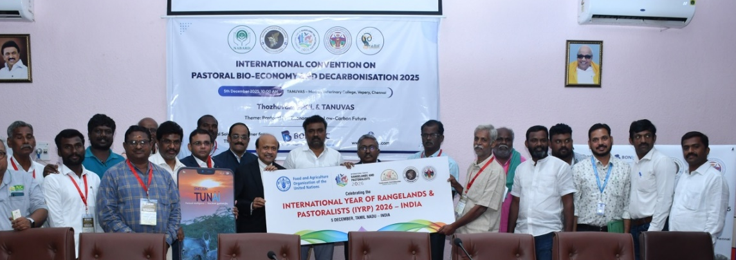

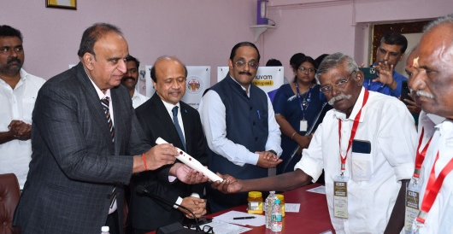
The convention opened with an overview by Dr P. Kabilan, Thozhuvam FPCL followed by formal unveiling of the Herders’ Digital Stick, an innovative technology jointly with BonbLoc Technologies. (the Digital Stick enables GPS-based documentation of grazing routes, mapping of water bodies, status of pastureland, real-time weather alerts and the capture of mobility-based carbon sequestration data). Migratory pastoralists of cattle and sheep represented and received the copies of book on claiming FRA 2006 rights. In the opening ceremony launching of IYRP 2026 was performed. Mr R. Anand, Chief General Manager of NABARD, stressed the importance of strengthening rural bio-economies and promoting innovation-driven livestock enterprises. Mr. C. Selwin Prabhu from the Tamil Nadu Seafood Exporters Association spoke on the need for integrated value chains across primary rural sectors. Dr. J. Navaneetha Krishnan of the Directorate of Animal Husbandry, Tamil Nadu Government briefed the population of livestock wise pastoral communities in Tamil Nadu. Mr. Durai Appadurai, Managing Director of BonbLoc Technologies, explained the digital architecture behind the pastoral technology platform. Dr. S. Satheesh Kumar, Dean (i/c) of MVC, expressed TANUVAS’s strong commitment to connecting pastoral research with climate science. In his presidential Address, Dr. R. Narendra Babu, Registrar and Vice-Chancellor (i/c) of TANUVAS, described pastoralism as one of the world’s most under-recognised nature-based climate solutions. He emphasised that mobility-based grazing regenerates grasslands, enhances soil carbon, conserves native breeds and strengthens rural socio-ecological resilience. The Chief Guest, Hon. Mr. Rajen Narasinghen, Junior Minister from the Republic of Mauritius, expressed his country’s interest in inviting individuals, organisations for investing sustainable technologies and also to utilize African Knowledge hub as Mauritius country enables. . 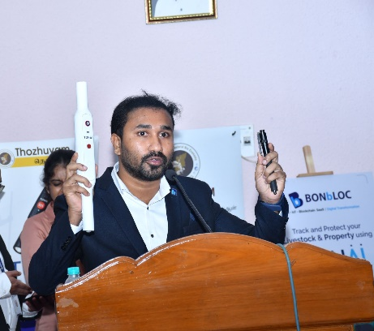

A series of special releases followed, including the IYRP 2026 Celebration Materials, the TUNAI Digital Network App, the Herders’ Digital Stick, Convention Proceedings Volume 2 (Tamil and English), the FRA Facilitator Guide in Tamil and a new Tamil book titled Livestock Farming Methods in a Changing Climate. These represented significant contributions to the pastoral knowledge base and demonstrated the capacity of local institutions to generate high-quality scientific and community-oriented publications.
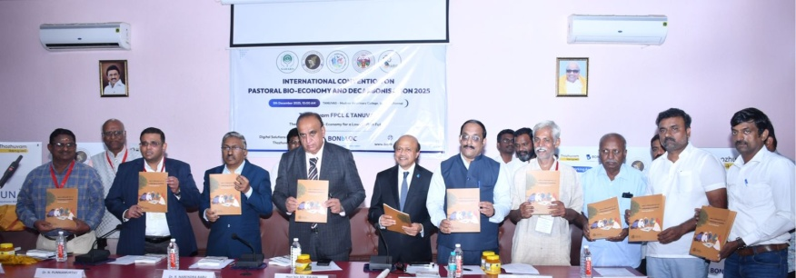
The technical sessions provided rich insights into the multi-dimensional nature of pastoralism. The first session, led by Mr. P. Vivekanandan of SEVA, positioned pastoralism within the global IYRP context and emphasised community stewardship. Dr. J. Balamurugan of TANGEDCO presented Thozhuvam’s bio-economy and decarbonisation framework, highlighting how livestock-based rural enterprises support climate mitigation. The BonbLoc team delivered the first public live demonstration of the TUNAI App and Digital Stick, marking a major milestone in India’s digital pastoral development.

The second session explored ethno-veterinary knowledge and pastoral-linked industries. Dr. Punniyamoorthi discussed the creation of One-Health eco-villages grounded in traditional healing systems. Mr. C. Anbumalar explained environmentally responsible leather value chains rooted in pastoral livelihoods. Dr. Meenatchi Sundaram presented conservation updates on native cattle breeds in Karnataka and Tamil Nadu.

The third session covered community-led carbon stewardship. Ms. Manya Singh presented case studies of carbon-positive pastoral interventions. Dr. M. S. Saravanan highlighted the ecological services of the Pulikulam cattle breed. Mr. S. Sathish Kumar of DESL demonstrated how manure-based Bio-CNG systems and service models can accelerate rural circular economy transitions.
In the fourth session, Thozhuvam FPCL and GPS Renewables explored how grassland biomass, livestock manure and pastoral waste streams can be transformed into energy, organic fertilisers and value-added products using microbial biotechnology. The session showcased opportunities for women and youth from pastoral communities to participate in emerging green economy sectors.

The final technical session showcased a live digital demonstration of real-time herder movement, pasture quality scoring, water-source mapping, village grazing land visualisation and carbon estimation. This positioned Tamil Nadu as the first Indian state to demonstrate a fully functional, integrated digital pastoral infrastructure.

A draft state-level resolution for IYRP 2026 emerged from the deliberations. It called for strengthening the pastoral bio-economy; establishing a Farmer Producer Company for all native breeds; collaborating with the national Ministry responsible for Climate Change to host a national Convention on Climate Change and Pastoral Decarbonisation in New Delhi in 2026; enabling state-wide adoption of the TUNAI App and Digital Stick; carrying out a full enumeration of Tamil Nadu’s pastoral economy; proposing a Pastoral Economy Development Board; conducting carbon reduction studies with TANUVAS and other academic institutions; and creating a digital map for all village panchayats to understand the status of grazing lands across the state. The event concluded with a strong collective commitment to recognising pastoralism as a climate-smart, eco-friendly and culturally grounded livelihood system with vast potential for decarbonisation, biodiversity conservation and rural prosperity. The collaboration between THOZHUVAM FPCL, TANUVAS, NABARD, TANGEDCO, SEVA, DESL, BONbLOC Technologies, GPS Renewables and pastoral communities marks a turning point in acknowledging the significance of pastoral systems in India. Tamil Nadu now stands at the forefront of building a digitally enabled, ecologically grounded pastoral future, perfectly aligned with the global observance of IYRP 2026.

For more information :
Thozhuvam Farmer Producer Company Ltd.
8, Nabard - Mabif, Madurai Agricultural College & Research Institute
thozhuvam@gmail.com, M: 9894406111

Tamil Nadu Veterinary and Animal Sciences University (TANUVAS)
Madhavaram Milk Colony, Chennai - 600 051. M: 9566082013

