PRESS RELEASE

FOR IMMEDIATE RELEASE: March 11, 2026 CONTACT: Mary Jo Foley, Director of Outreach
Society for Range Management
srmoutreach@rangelands.org
P: 303-986-3309

Waters-Bayer, Niamir-Fuller and Hutchinson Honored by Society for Range Management with Renner Award
MONTEREY, CALIFORNIA — The Society for Range Management (SRM) honored Dr. Ann Waters-Bayer, Dr. Maryam Niamir-Fuller, and Dr. Barbara Hutchinson with the Frederic G. Renner Award at SRM’s 79th Annual Meeting in Monterey, California earlier this year.
The Renner Award is the most prestigious honor bestowed by the Society for Range Management. The award was made possible by a generous contribution from Frederic G. Renner, a Charter and Life member and SRM’s second President (1949). It is presented with the belief that such recognition fosters better use of rangeland resources and a broader understanding of the contributions these resources make to the welfare of all people.
Drs. Waters-Bayer, Niamir-Fuller, and Hutchinson were recognized for their leadership in advancing global collaboration around rangelands and pastoralist systems, including their pivotal roles in the international effort that led to the United Nations designation of 2026 as the International Year of Rangelands and Pastoralists (IYRP).
Dr. Ann Waters-Bayer, an agricultural sociologist, has spent decades advancing participatory agricultural research and pastoral development through organizations including the International Livestock Centre for Africa (which became part of the International Livestock Research Institute), the ETC Foundation, and the Agrecol Association for AgriCulture & Ecology. She continues to support global rangeland initiatives through the Global Alliance for Rangelands & Pastoralists and related international partnerships. She is currently Associate Research Fellow with the German Institute for Tropical and Subtropical Agriculture (DITSL).
Dr. Maryam Niamir-Fuller served in multiple leadership roles within the United Nations system, including Director of the Global Environment Facility Division at the United Nations Environment Programme and Special Advisor on the Sustainable Development Goals. She helped lead major international rangeland and environmental initiatives, having served as Co-Chair of the International Support Group for the International Year of Rangelands and Pastoralists, and is currently the Senior Advisor for the Global Secretariat of the Global Alliance for Rangelands and Pastoralists.
Dr. Barbara Hutchinson has been instrumental in advancing rangeland information systems and global collaboration networks through efforts such as the Global Rangelands Initiative and the Rangelands Partnership. She continues to support international coordination for the International Year of Rangelands and Pastoralists, including management of global communications and information platforms. She is currently Librarian Emerita of Natural Resources & the Environment with the University of Arizona.
For their outstanding leadership and contributions to advancing rangeland stewardship and pastoralist communities worldwide, the Society for Range Management is proud to recognize Dr. Ann Waters-Bayer, Dr. Maryam Niamir-Fuller, and Dr. Barbara Hutchinson with the Frederic G. Renner Award.
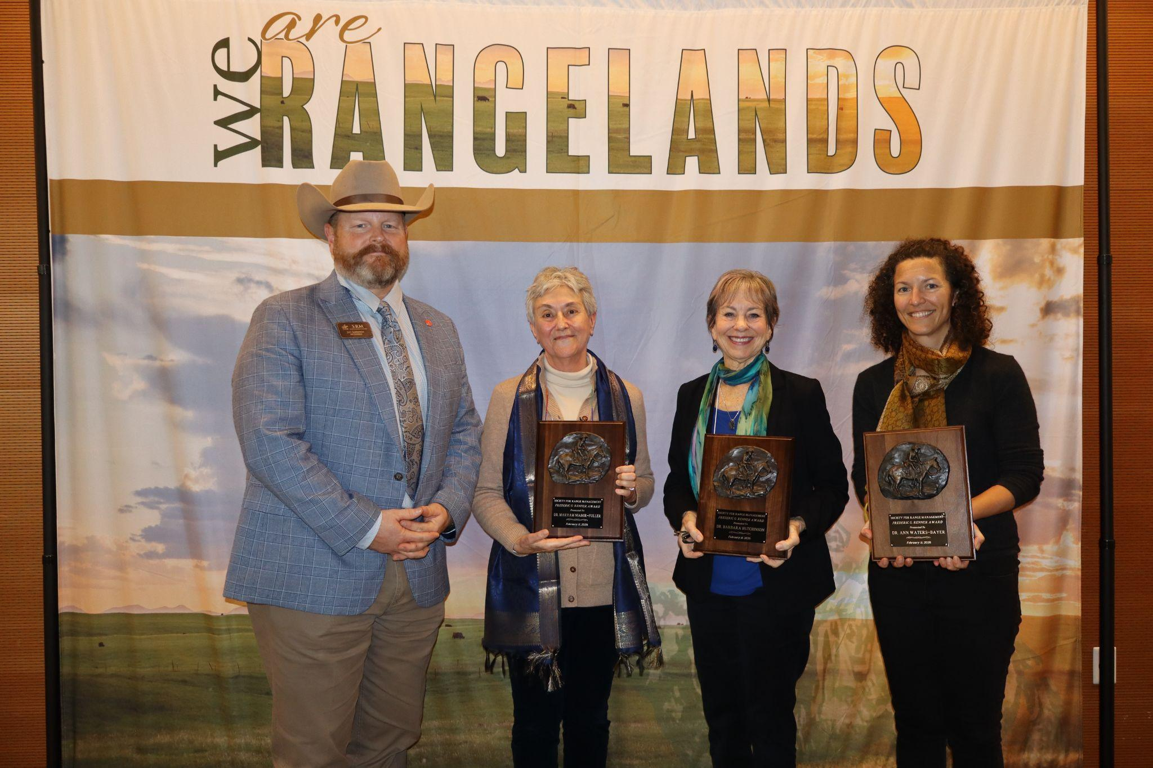
SRM 2025 President Jeff Goodwin presents the Frederic G. Renner Award to Dr. Maryam Niamir-Fuller, Dr. Barbara Hutchinson and Dr. Ann Waters-Bayer (accepted on her behalf by Lauren Svejcar)

