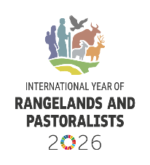

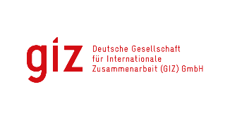
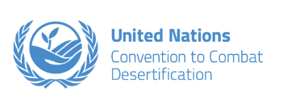
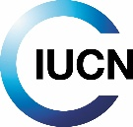
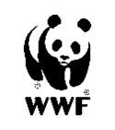

Concept Note: Regional Dialogue Sessions on Integrated Rangelands Management Sustainable Pastoralism
V2. November 2025

Background
Rangelands, composed of grasslands, savannahs, drylands, and other grazing lands, cover extensive areas globally and provide critical ecosystem services at a variety of scales - supporting biodiversity, rural livelihoods, and climate resilience. Globally, around 500 million pastoralists rely on livestock herding for food and income, as well as a store of wealth that acts as collateral or as a safety net in times of need. When well-managed, these extensive livestock production systems have significant potential to contribute to rural economies, biodiversity conservation, and carbon sequestration across vast iconic landscapes.

Despite their importance, rangelands remain under significant threat from land conversion as well as the impacts of land degradation, biodiversity loss, climate change and drought. The UNCCD COP16 decision calls on nations to prioritize policies and investments that promote the conservation, sustainable management, and restoration of rangelands – in line with land degradation neutrality (LDN) targets and other environmental and development priorities.

These regional dialogue sessions will convene UNCCD national focal points and government representatives, as well as key partners and stakeholders to discuss region-specific challenges and opportunities, and how to advance more inclusive policies that improve the design, planning, implementation, monitoring, and finance for rangeland and pastoralist initiatives.

Objectives
- Facilitate knowledge exchange on best practices and opportunities for integrated rangeland management across regions.
- Build the foundation and generate political momentum for a Coalition on Rangelands and Pastoralists to mobilize a coordinated global response to the complex challenges facing rangeland and pastoralism.
- Support countries in implementing the UNCCD COP16 decision by identifying policy, financial, and institutional pathways for rangeland restoration and sustainable livestock systems.
- Strengthen regional networks and mainstream rangeland priorities into national climate, biodiversity, and land-use strategies (NDCs, NBSAPs, LDN targets).

Format and Structure
- Three Regional webinars:
  - Africa (English, French, Portuguese)
  - Latin America (English, Spanish, Portuguese)
  - Asia and Arab region (English, Russian, Chinese, Arabic)
- One global webinar for the focal points of all three Rio conventions ((CBD, UNCCD, and UNFCCC).
- Briefing packages distributed in advance, including an agenda, information notes, and links to key references (e.g., GLO Thematic Report on Rangelands and Pastoralists, ELD report on the economics of rangeland restoration, WWF report on ecosystem services and conservation priorities).
- Outcomes synthesized and shared via relevant networks, including the International Year on Rangelands and Pastoralists 2026, the Global Grasslands and Savannahs Dialogue Platform and the IKI Regional Knowledge Platform for Grasslands and Savannahs in Latin America (launching Q1 2026).

Partners
- UNCCD secretariat and Global Mechanism
- WWF Germany
- IUCN Forests and Grasslands Team
- GIZ
- UNCBD
- IYRP (incl. regional networks)
- ILRI

Expected Outcomes
- Enhanced understanding among national focal points of the cultural, ecological and economic value of rangelands and their role in achieving LDN, climate, and biodiversity targets.
- Clarity on the UNCCD COP16 rangelands decision and its implications for national policy and investment.
- Strengthened regional coordination and capacity to integrate sustainable rangeland management into national spatial planning frameworks.
- Expansion of a global stakeholder network in support of the International Year of Rangelands and Pastoralists 2026.

Proposed Dates and Times
- Africa (English/French/Portuguese): February 04th: Tuesday/Wednesday 14:00–15:15 UTC
- Latin America & Caribbean February 10th (English/Spanish/Portuguese): Tuesday/Wednesday 16:00–17:15 UTC
- Asia and Arab Region (English/ Chinese/Russian/Arabic): 12th Wednesday/Thursday 08:00–09:15 UTC
- Synergies dialogue to take place in March/April 2026

