Focusing on Women and Youth Power, Talking about Sustainable Development Future of Rangelands and Pastoralism
IYRP Symposium

Chaired by Sargai Sha(IYRP Gender and Pastoralism working group volunteer)

On October 25, 2025 at 3:00 pm, a symposium focusing on "Women and Young Pastoralists Development in the Framework of the International Year of Rangelands and Pastoralists (IYRP 2026)" was successfully held to gather grassroots wisdom to promote the sustainable development of global rangelands and pastoralism.
At the symposium, participants discussed the current status of rangelands and pastoralist systems globally, identifying rangelands as key ecosystems covering more than 54% of the Earth's land area and the important role of pastoralism in supporting populations in arid and semi-arid areas, while confronting the challenges of rangeland degradation and policy neglect. The IYRP 2026 initiative focused on the core concept of "nothing about us without us", emphasizing the importance of multi-stakeholder collaboration in improving the livelihoods of pastoralists.。
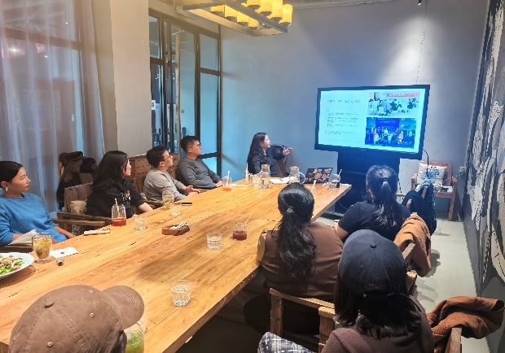
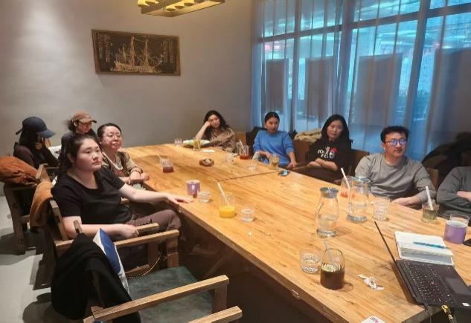

The symposium brought the issue of women pastoralists to the forefront. It was pointed out that women pastoralists have made outstanding contributions in areas such as dairy processing and traditional knowledge transmission, but at the same time they face difficulties such as limited land rights and low participation in decision-making, etc. The Mera+15 Global Women Pastoralists Gathering to be held in May 2026 in Nepal, as well as the policy briefs and thematic film festivals previously launched, provide an effective path to empower women pastoralists and promote policy change. The Mera+15 Global Women Pastoralists' Gathering in Nepal in May 2026, as well as previous activities such as policy briefs and thematic film festivals, provide effective pathways to empower women pastoralists and promote policy change.
The development of young pastoralists has also received much attention. In response to problems such as the outflow of young people and the diminishing sense of traditional identity, the conference proposed empowering young people through capacity training, network building and technological innovation. For example, the upcoming International Youth Pastoralist Gathering in Madrid, Spain, and the strategic advancement of the IYRP Youth Working Group will help young people become the core force for modernization and sustainable development of the pastoral industry.
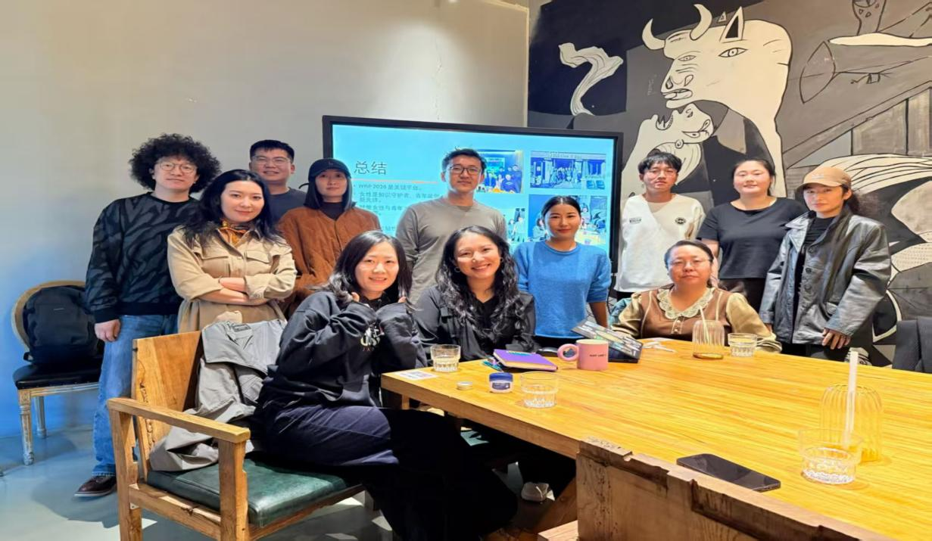
By focusing on the two major groups of women and youth, the symposium further clarified the practical direction of IYRP 2026, injected ideological impetus for the construction of a more resilient and inclusive global rangeland pastoral system, and also laid the foundation for the subsequent implementation of related actions.

