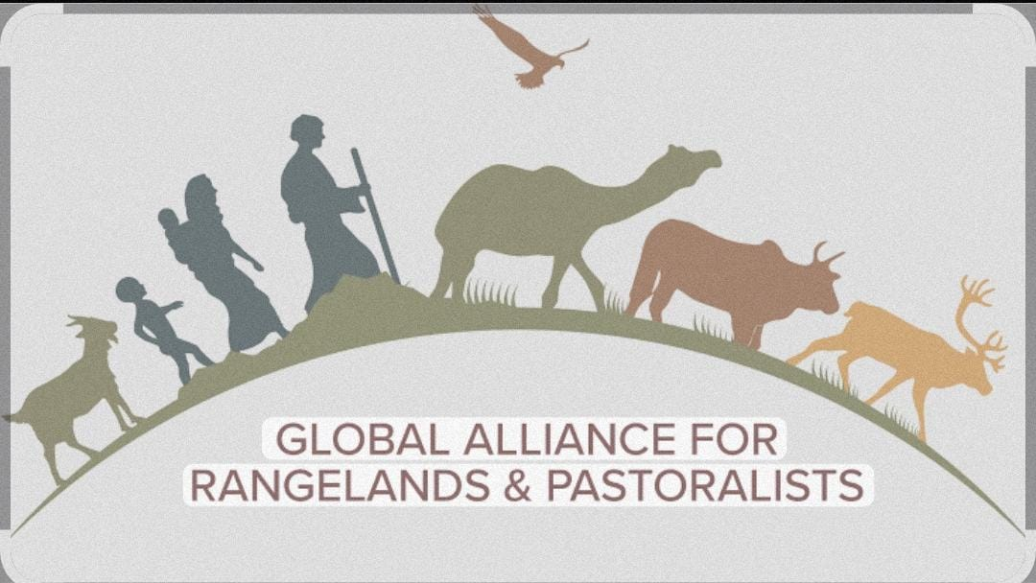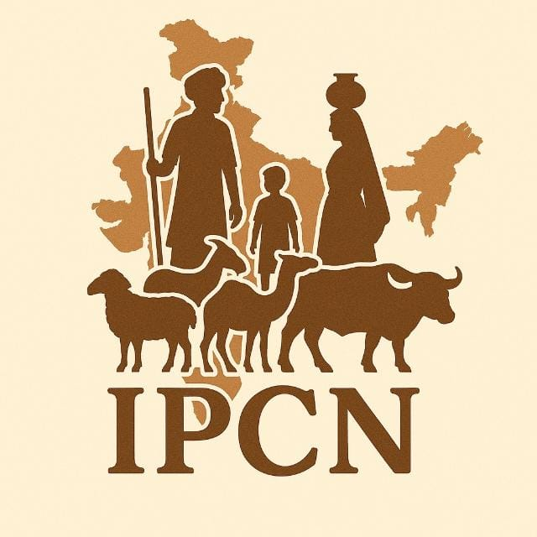
Launch/Celebration of IYRP in Rajouri District of Jammu & Kashmir, India
Dated: 16-02-2026
Venue: Prori Gujjaran, District Rajouri, J&K
Time. 11:00 am

On 16th February 2026, an event was successfully organized by Highland Pastoralist Alliance (HPA) with Indian Pastoralist Communities Network (IPCN) in village Prori Gujjaran district Rajouri of J&K to celebrate the International Year of Rangelands and Pastoralists IYRP, 2026. The program aimed to raise awareness about the importance of rangelands, pastoralist communities and sustainable development based livestock for livelihood in the Himalayan region.
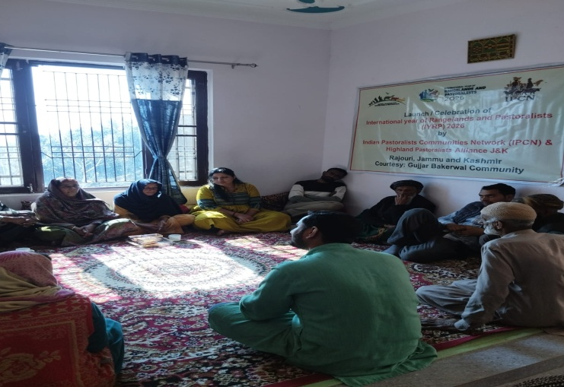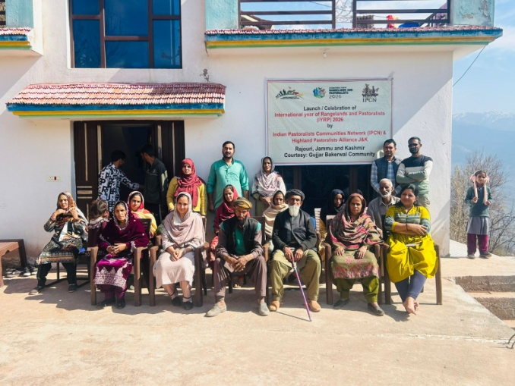
In Jammu members of IPCN met with Dr Shahid Iqbal Choudhary and had detailed discussion on celebration of IYRP in J&K in May month this year.
The event brought together Gujjar Bakerwal pastoralist community members, youth, women and social activist to recognize the cultural and ecological contribution of pastoralists.
Main objective of the event:
- To celebrate IYRP and promote awareness about rangeland conservation.
- To highlight the role of pastoralist community in biodiversity conservation.
- To showcase traditional culture indigenous knowledge and sustainable practice.
Community Dialouge: An open discussion session was conducted where participants shared.
- Issued related to grazing rights.
- Access to forest resources.
- Climate change impacts.
- Migration challenge.

Conclusion:
The presence of local community members reflected strong local support for rangeland conservation and pastoral rights. The local convener of this event was Tariq Aziz a young Gujjar pastoralist research scholar president of Highland Pastoralist Alliance whereas members of IPCN Bhavana Desai from Gujarat and Mohd Ameer Hamza from Uttarakhand were organizer of this program.

Tariq Aziz
Member Indian Pastoralists Communities Network IPCN & Highland Pastoralists Alliance.
Rajouri, Jammu and Kashmir
tariqcuj@gmail.com
3.3.2026

