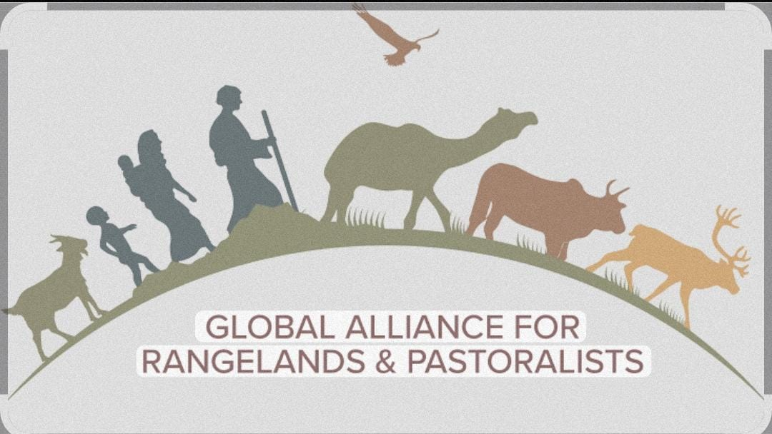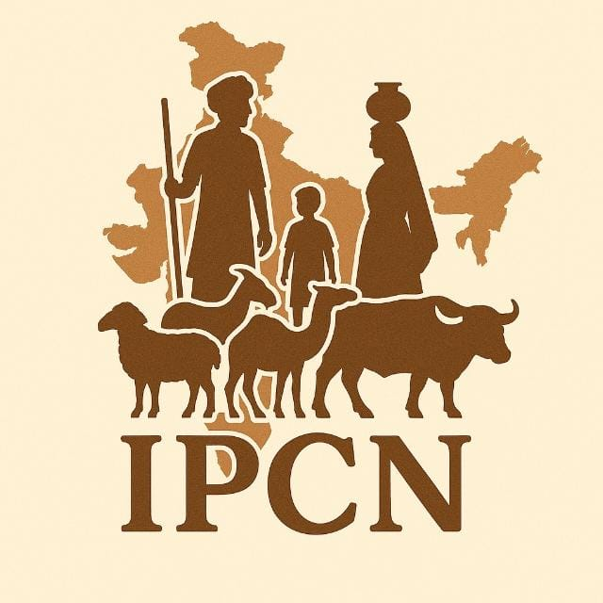
Launch/Celebration of IYRP in Chamba District of Himachal Pradesh
Dated: 15-02-2026
Venue: Chamba H.P
Time. 11:00 am

On 15th February 2026, an event was successfully organized by Indian Pastoralist Communities Network (IPCN) in Chamba district of Himachal Pradesh to celebrate the International Year of Rangelands and Pastoralists IYRP, 2026. The program aimed to raise awareness about the importance of rangelands, pastoralist communities and sustainable development based livestock for livelihood in the Himalayan region.
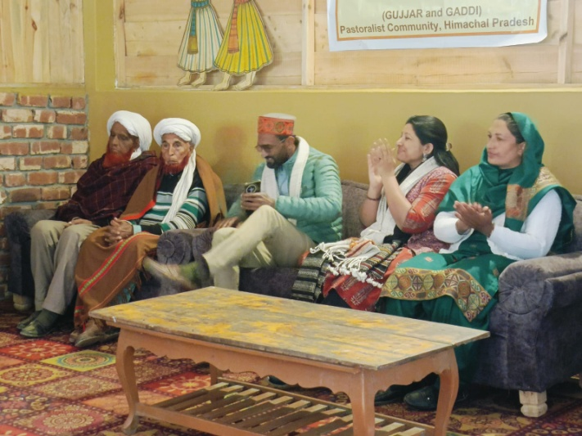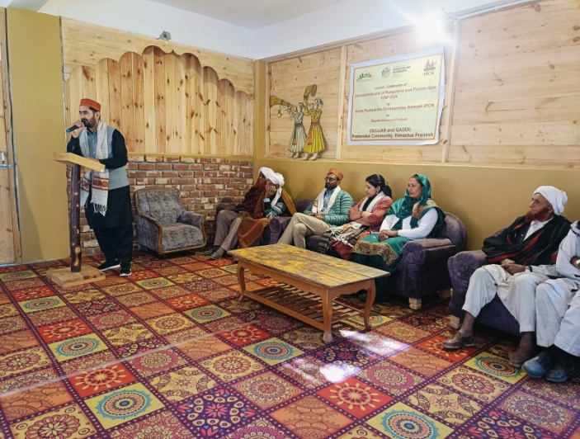
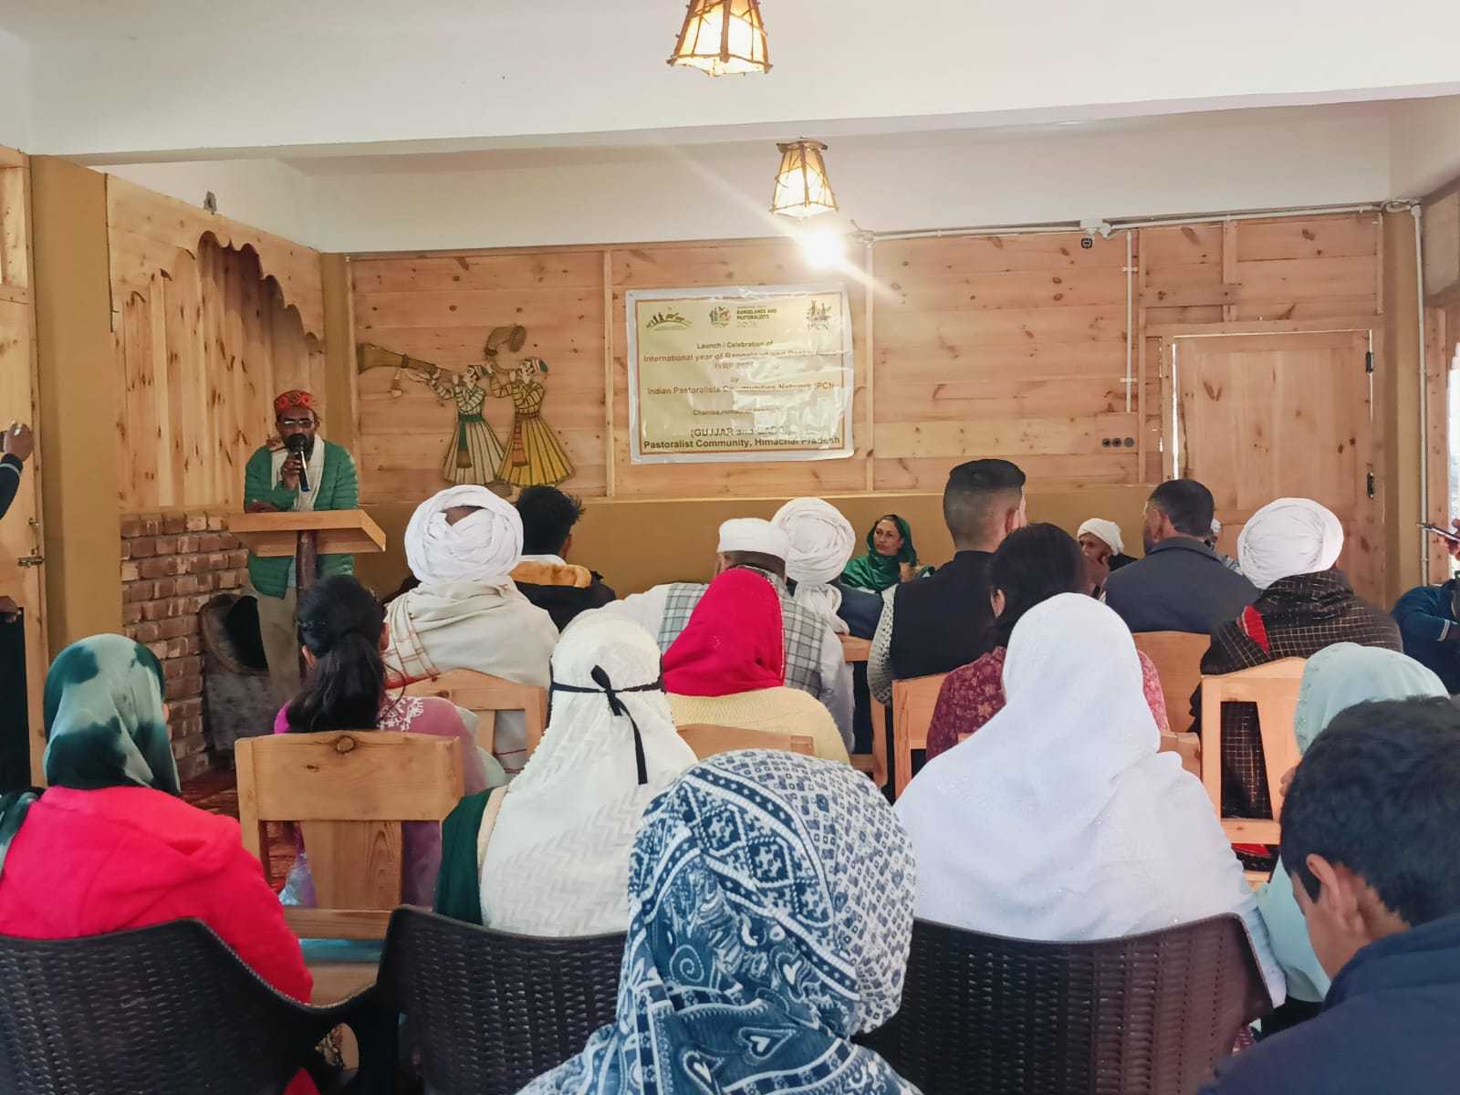
The event brought together Gujjar and Gaddi pastoralist community members youth, women and social activist to recognize the cultural and ecological contribution of pastoralists.
Main objective of the event:
- To celebrate IYRP and promote awareness about rangeland conservation.
- To highlight the role of pastoralist community in biodiversity conservation.
- To showcase traditional culture indigenous knowledge and sustainable practice.
Community Dialouge: An open discussion session was conducted where participants shared.
- Issued related to grazing rights.
- Access to forest resources.
- Climate change impacts.
- Migration challenge.
Conclusion:
The presence of local community members reflected strong local support for rangeland conservation and pastoral rights. The local convener of this event was Mohd Rafeek a young Gujjar pastoralist whereas members of IPCN Bhavana Desai from Gujarat, Mohd Ameer Hamza from Uttrakhand and Tariq Aziz from J & K were organizer of this program.

Tariq Aziz
Member Indian Pastoralists Communities Network IPCN & Highland Pastoralists Alliance.
Rajouri, Jammu and Kashmir
tariqcuj@gmail.com
3.3.2026

