Seminar on “Save the Tanks, Protect Livestock”
Organised by Professional Assistance for Development Action (PRADAN) Date: 29 August 2026
Venue: CESCI Campus, Kadavur, Madurai, Tamil Nadu, India
Summary of the Proceedings

Introduction to Tanks
Tamil Nadu’s traditional tanks, locally known as eri, kanmai and kulam, are important common resources that support agriculture, livestock, and rural livelihoods. Historically, tanks were not designed solely for irrigation; they formed part of a wider landscape in which water, grazing areas, agricultural fields, vegetation, and livestock were closely interconnected. For livestock keepers, tank water is an important source of drinking water for cattle, goats, sheep, and other livestock, particularly during dry periods when other water sources become scarce. Tank beds, bunds, foreshore areas, and associated commons also provide seasonal grazing resources, especially after water levels recede and crops are harvested. Native grasses and other vegetation growing around tanks contribute to livestock feed and help reduce livestock keepers’ dependence on purchased fodder.
Siltation, encroachment, the spread of Prosopis juliflora, degradation of grazing areas, blocked feeder channels, and declining water availability can reduce the resources available to livestock. As tank commons deteriorate, livestock keepers may have to travel longer distances to access water and grazing areas, spend more on fodder, or reduce the number of animals they maintain.
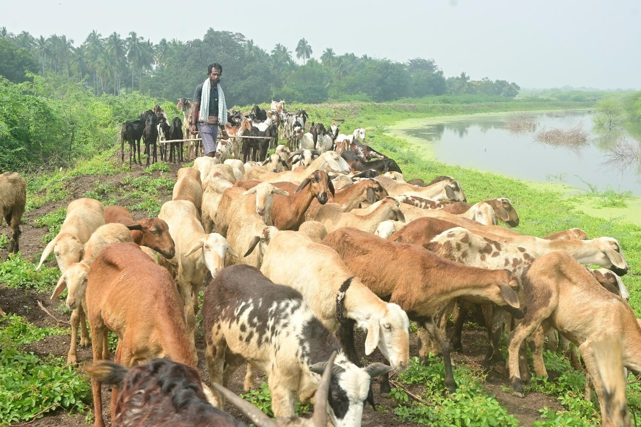
Figure 1 Sheep grazing on a rehabilitated tank bund, Virudhunagar district

The Seminar
Recognising the close relationship between tanks and livestock, PRADAN organised a seminar titled “Save the Tanks, Protect Livestock” on 29 August 2026 at the CESCI Campus, Kadavur, Madurai.

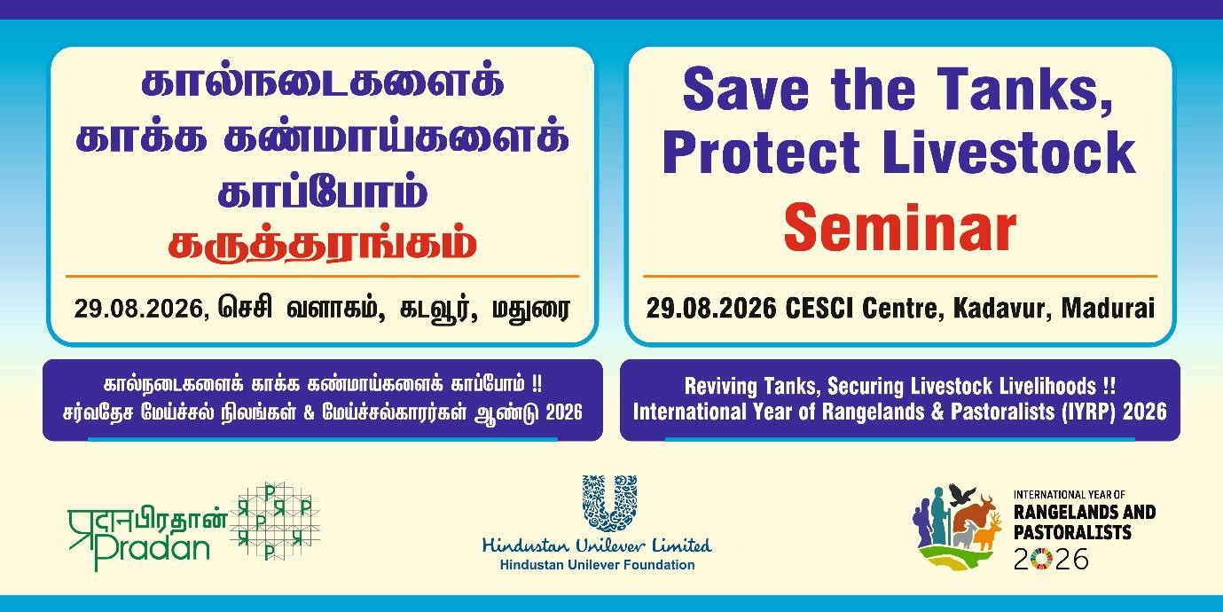
Figure 2 Banner for the Seminar

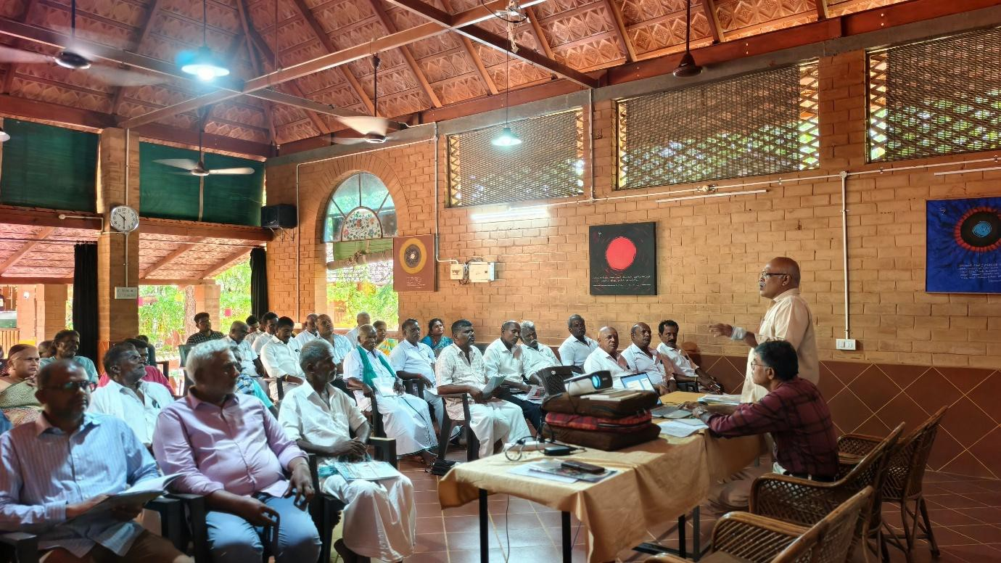
Figure 3 R. Seenivasan, PRADAN staff, introduces the objectives of the Seminar
A total of 49 participants attended the seminar. These included 33 livestock keepers and 16 from NGOs, researchers and activists working on livestock development. Most participants were actively engaged in livestock rearing and tank rehabilitation activities. Their experiences

and perspectives contributed significantly to discussions on tank restoration, access to water for livestock, grazing resources, and the sustainable management of common water bodies.

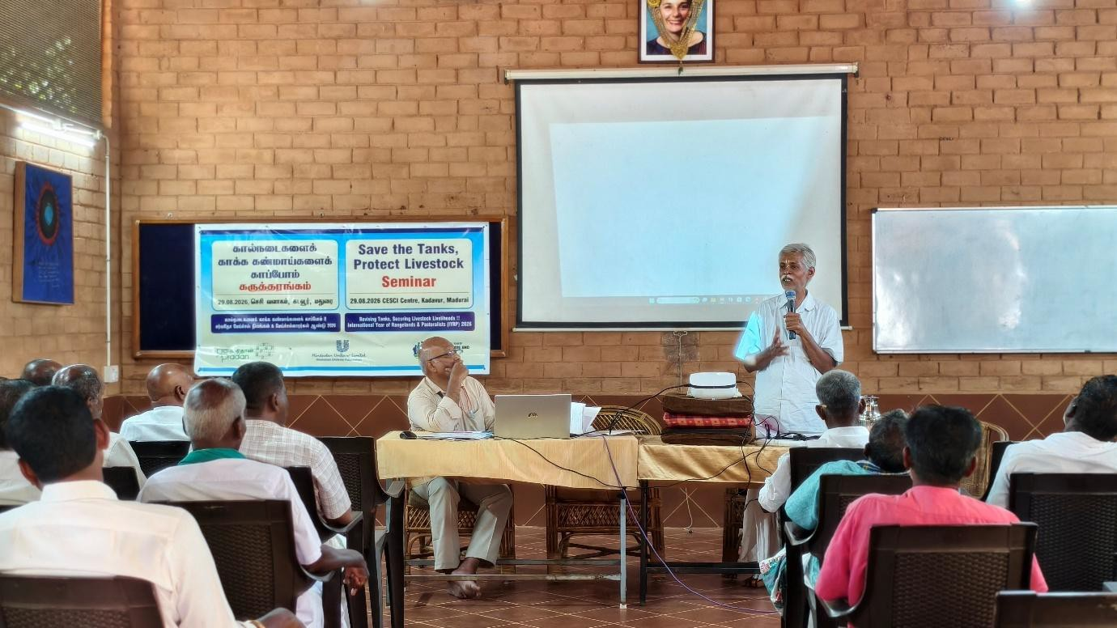
Figure 4 P. Vivekanandan, Coordinator, IYRP 2026 introducing IYRP

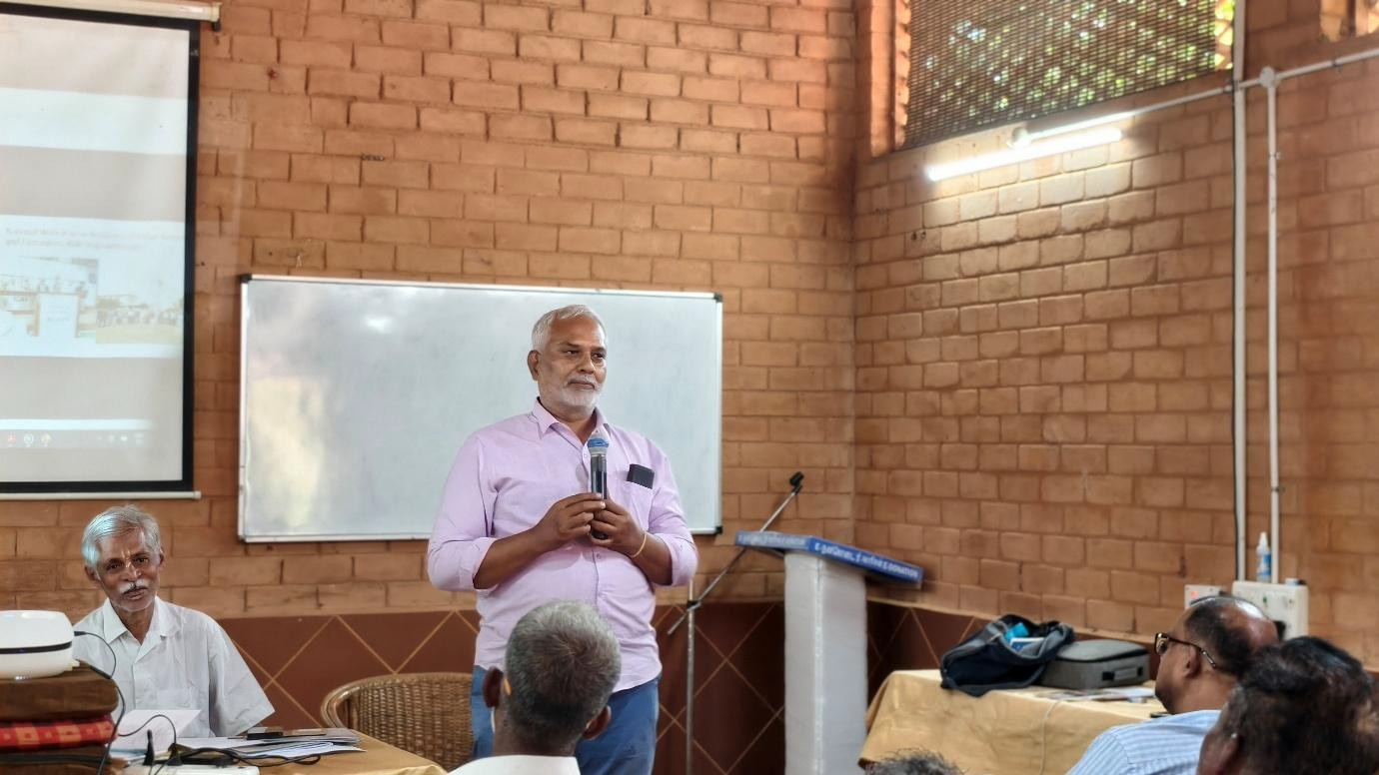
Figure 5 Mr Muthuvelayudham sharing CCDs livestock development work
Four detailed presentations on the role of tanks in livestock economy, present issues and problems affecting livestock, how to do water, grazing development in scale at the level of the district and what is to be done to remedy the situation were presented and discussed.

Mr. Rajiv Gandhi of the Tamil Nadu Federation of Pastoral Peoples Sangam highlighted the role of tanks in providing grazing grounds and waterholes for livestock. In recent years,
unscrupulous fishery contractors have restricted cattle from accessing tanks or emptied the water without ensuring access to drinking water for livestock. Although pastoralists have customary rights to access these resources, these rights are often not respected. He highlighted the Federation’s efforts to secure relevant amendments to the contracts entered into by government departments and fishery contractors. He also emphasised the need for tank rehabilitation projects to incorporate waterholes and other provisions that support
livestock rearers.

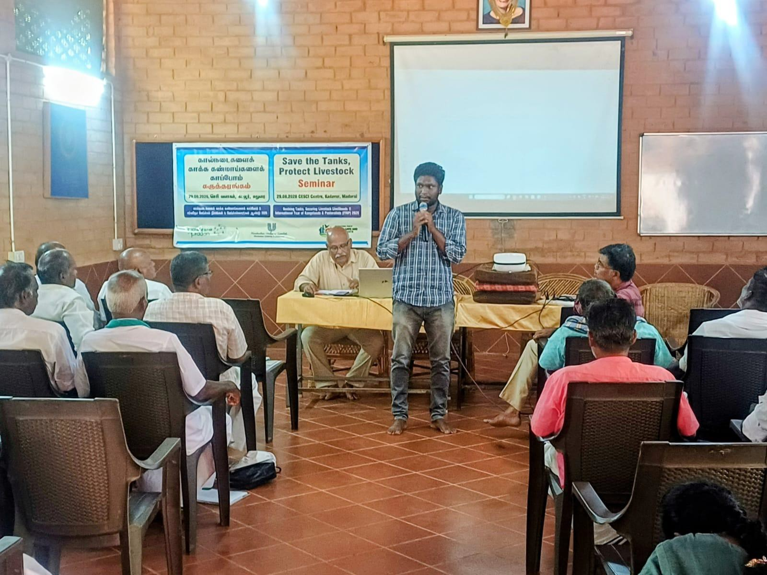
Figure 6 Mr Rajiv Gandhi, President, TFPPS deliberating on the issues associated with access to water and grazing in tanks

Discussion on Key Challenges Faced by Livestock Keepers
The participants identified several key challenges affecting livestock-based livelihoods and access to common grazing and water resources:
- The spread of Prosopis juliflora (Prosopis) has significantly reduced the availability of grazing areas. The species was introduced in Tamil Nadu in 1875, primarily to provide wood for fuel and energy. Over time, however, it became highly invasive and spread extensively across tank beds, bunds, and channels, reducing the area available for grazing.
- Dense Prosopis growth prevents grasses and other fodder plants from regenerating, thereby reducing the availability of natural fodder for livestock.
- The declining water-storage capacity of tanks has increased water scarcity for livestock, particularly during dry periods.
- Livestock keepers increasingly face difficulties in accessing tank water, especially where access points have been blocked or tank resources have deteriorated.
- Dense Prosopis thickets and thorny vegetation restrict livestock movement and limit access to available grazing areas. The thorns can also cause injuries to animals.
- The discharge of sewage and wastewater into tanks is increasingly affecting the quality and safety of water resources, creating additional risks for livestock that depend on tanks for drinking water.

Livestock Population Trends: 2007, 2012 and 2019
The livestock population data presented during the seminar show significant changes in Tamil Nadu between 2007 and 2019. The figures below are presented in lakhs.
Table 1 Livestock population 2007 to 2019

Livestock Category | 2007 | 2012 | 2019
Cow | 111.89 | 88.14 | 95.19
Buffalo | 20.09 | 7.80 | 5.19
Sheep | 79.91 | 47.87 | 45.00
Goat | 92.75 | 81.43 | 98.89
Pigs | 2.84 | 1.84 | 0.67
Total | 307.47 | 227.08 | 244.93

Changes in Livestock Population, 2007–2019

Overall, the total livestock population declined in Tamil Nadu by approximately 20% between 2007 and 2019. The changes varied considerably across livestock categories:

- Cows: decreased by 15%
- Buffaloes: decreased by 74%
- Sheep: decreased by 44%
- Pigs: decreased by 76%
- Goats: increased by 7%
The data indicate a substantial decline in buffalo, sheep, and pig populations, while goat numbers increased slightly. The decline in livestock populations, particularly grazing-

dependent species such as sheep, needs to be considered alongside the deterioration of grazing commons and the reduced availability of water and fodder resources.

Discussion on Region-wise Livestock Population
The regional analysis presented during the seminar indicates that livestock populations declined across most regions of Tamil Nadu between 2007 and 2019. The Western region was the only region to record an overall increase in livestock population.
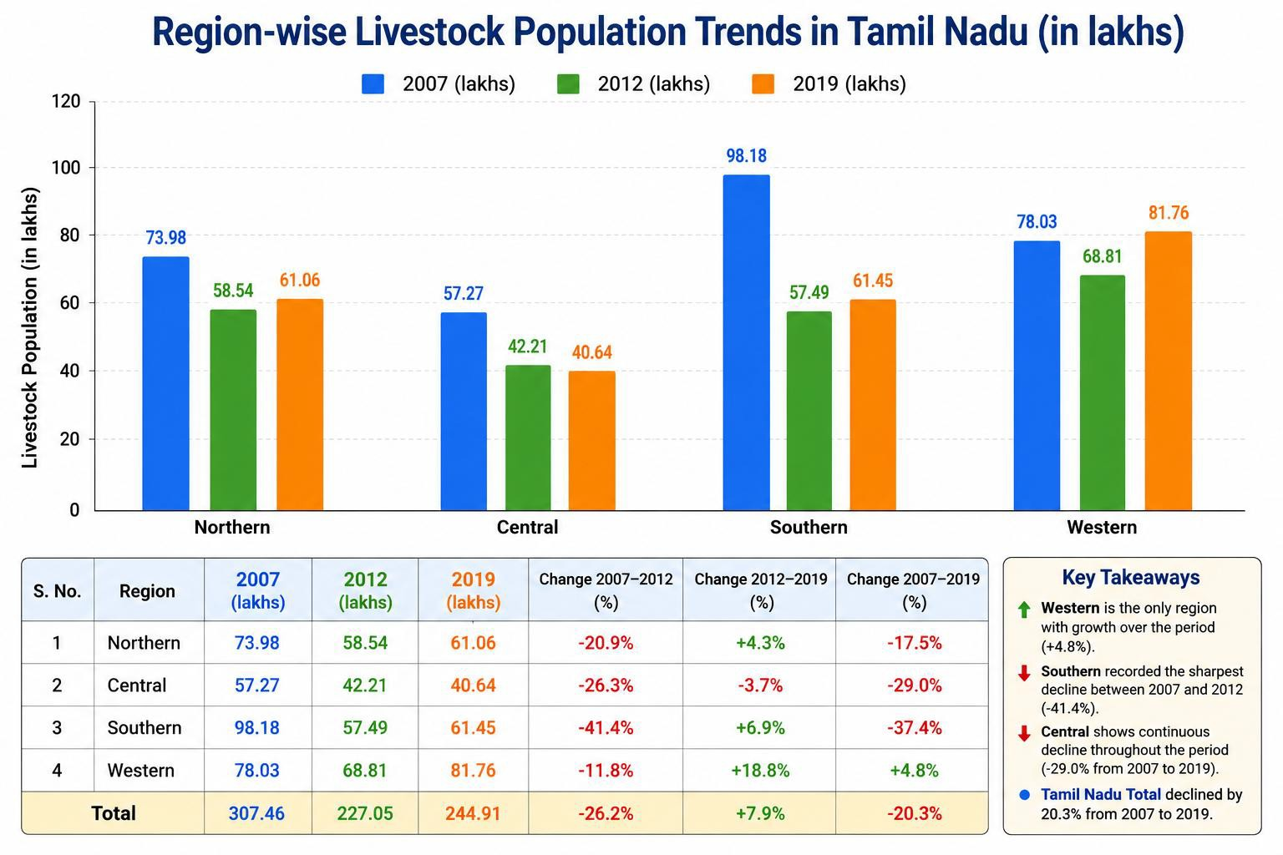
Figure 7 Regionwise livestock population trends 2007-2019
This regional variation suggests that changes in livestock populations are influenced not only by broader trends in livestock rearing but also by differences in access to water, grazing resources, agricultural systems, and other livelihood opportunities across regions.

Livestock Density in Tank-Intensive Districts
The following data illustrate the relatively high livestock density in selected tank-intensive districts of Tamil Nadu. All these districts are agriculturally intensive areas with seasonal irrigated and rainfed cultivation .
Table 2 Livestock density per sq.km (100 ha)

Tank Intensive District | Livestock per 100 ha
Dharmapuri | 246
Krishnagiri | 268
Madurai | 198
Pudukkottai | 221
Ramanathapuram | 192
Sivaganga | 190

Virudhunagar | 286
Livestock density in these districts is higher than the national and state averages. This can be attributed, in part, to the availability of tanks and their associated landscapes, which provide important sources of water and grazing resources within intensively cultivated areas.

Livestock and Grazing Landscapes in Southern Tamil Nadu
Table 3 Livestock grazing areas available across southern districts of Tamil Nadu

District | Permanent pasture (% of geographical area) | Net sown area (%) | Estimated tank-bed area (%) | Livestock, 2019 (lakh)
Pudukkottai | 0.7 | 25.3 | 10 | 9.77
Ramanathapuram | 0.0 | 43.5 | 10 | 7.78
Sivaganga | 0.3 | 22.3 | 10 | 7.65
Virudhunagar | 0.2 | 30.5 | 8 | 11.39

The discussion highlighted that permanent grazing lands are almost non-existent in these districts. As a result, tank beds, bunds, and channel networks, together with agricultural fallows after seasonal cultivation, constitute the major grazing areas available to livestock. This highlights the importance of tanks and their associated commons as part of the wider livestock landscape in southern Tamil Nadu. Their ecological condition and accessibility have a direct bearing on the availability of water and grazing resources for livestock keepers.

Discussion on PRADAN Project Interventions in Virudhunagar
PRADAN implements several water and land development projects across Tamil Nadu. As a case study, the seminar presented PRADAN’s programme in Virudhunagar district, where 227 tanks have been rehabilitated in four years (2022-26). The interventions included strengthening and widening approximately 148 km of tank bunds, excavating around 180 km of channels, repairing 53 community ponds, and excavating 973 farm ponds. Approximately 742 ha of Prosopis thickets have also been removed from tank and common areas. Though these are water development works principally aimed at irrigated agriculture but they do serve livestock because the rearers have customary rights to use them for grazing and watering animals.
In addition, around 4,120 ha of Prosopis have been removed from private agricultural lands. These areas become available for seasonal grazing after farmers complete their crops, thereby expanding the grazing resources available to livestock keepers.
Together, these interventions support approximately 2.83 lakh livestock by improving access to water and grazing resources across tank beds, bunds, channels, and associated commons. The interventions demonstrate how the restoration of water bodies and common lands can contribute not only to improved water availability, but also to the restoration of grazing resources, livestock welfare, and the resilience of livestock-based livelihoods.

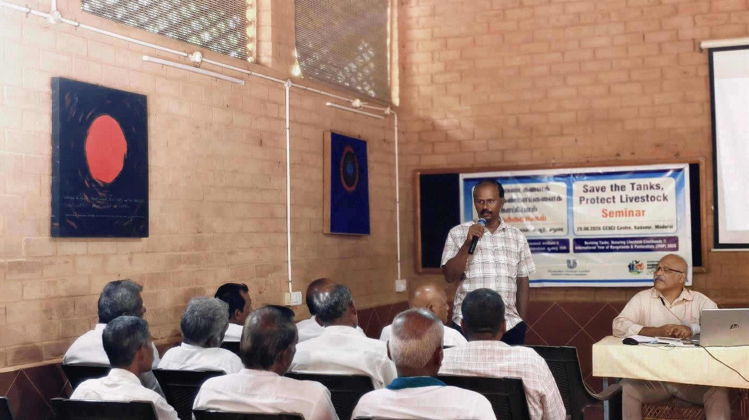
Figure 8 P. Mohan explaining PRADAN interventions

Group Discussions
Participants were divided into three groups, and each group discussed the following questions:
- What are the problems faced by livestock keepers?
- What are the possible solutions?
- What lessons can be learned from field experiences?
The group discussions provided an opportunity for livestock keepers to share their practical experiences and collectively identify locally relevant solutions.
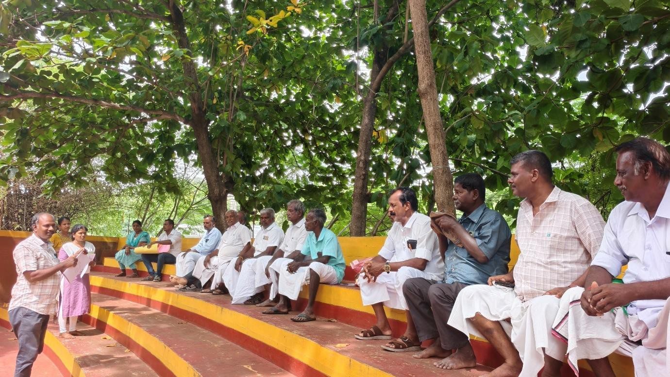
Figure 9 Group discussion with livestock keepers

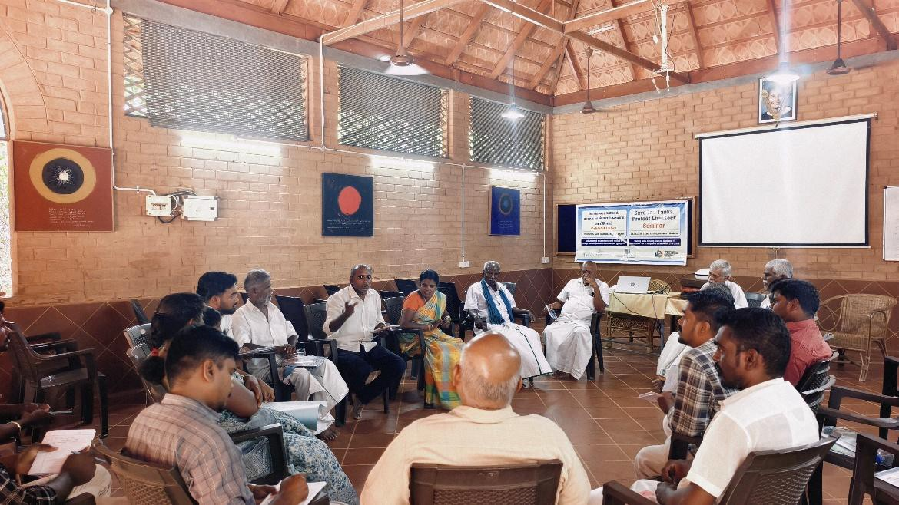
Figure 10 Group Discussion on problems faced by livestock keepers

Problems Faced
The participants identified the following key challenges:
  - Spread of Prosopis (Prosopis juliflora) in tanks and supply channels: This reduces water availability and grazing areas and increases the risk of livestock injuries from the plant’s thorns.
  - Plastic waste in tanks: Plastic waste poses health risks to livestock that use tanks for drinking water or grazing.
  - Encroachment of tanks and supply channels: Encroachments reduce the area available for water storage, drainage, grazing, and livestock movement.
  - Poor water quality and wastewater contamination: The entry of sewage and wastewater into tanks affects the quality and safety of water available to livestock.
  - Attacks by stray dogs: Stray dogs pose a threat to livestock, particularly sheep and goats.
  - Inadequate and delayed veterinary services: Livestock keepers face difficulties in accessing timely veterinary care, medicines, and other essential services.
  - Limited awareness of livestock diseases and prevention: Lack of information on disease prevention, vaccination, and livestock management increases risks to animal health.
  - Restrictions on goat grazing: Restrictions on access to grazing areas affect the livelihoods of goat rearers.
  - Difficulties in livestock management during the rainy season: Heavy rains and waterlogged conditions create additional challenges for grazing, movement, and livestock management.
  - Livestock theft and associated economic losses: Theft of animals creates significant financial losses for livestock-keeping households.
  - Low and fluctuating meat prices: Unstable market prices reduce the economic returns from livestock rearing.

  - Conflicts between farmers and livestock rearers: Livestock entering cultivated fields and causing crop damage can lead to conflicts between farmers and livestock keepers.
  - Fishery cultivation through contractors affect the water availability for livestock.

Suggested Solutions
The participants proposed the following measures:
  - Construct dedicated drinking-water structures for livestock.
  - Regularly remove Prosopis from tanks, channels, and grazing areas.
  - Extend government subsidies and support programmes to goat rearers.
  - Improve access to veterinary medicines and services.
  - Prevent wastewater from entering tanks and supply channels.
  - Conduct regular awareness programmes on disease prevention, vaccination, and livestock management.
  - Provide fencing around grazing areas and livestock resting or penning areas.
  - Take effective action against encroachments on tanks, channels, and grazing commons.
  - Install CCTV cameras at livestock resting and penning locations to reduce livestock theft.
  - Promote balanced approaches that recognise both the importance of tree conservation and the livelihood needs of goat rearers.

Key Lessons Learned from local action
The discussions highlighted examples of villages where local communities have collectively decided to eradicate Prosopis and have successfully done so. These efforts were driven largely by concerns about the impact of Prosopis on livestock and the loss of grazing resources.
Two case studies were shared by villagers, illustrating how communities removed Prosopis entirely from common areas with a combination of PRADAN’s support and their own resources.
  - T. Kiliyur, Thiruvadanai Union: Community members across different generations actively participate in the removal of Prosopis. Their collective effort has helped restore grazing resources and improve access to common lands.
  - Gopalapattinam, Nainarkovil Panchayat Union: The community continues to actively remove Prosopis from common areas, demonstrating sustained local commitment to protecting grazing resources.
The discussions showed that community participation is central to the restoration and sustainable management of tanks and grazing commons. When livestock keepers and other local communities are involved in project planning, their needs and expectations can be incorporated into interventions. The experiences from these villages demonstrate that local collective action, supported by appropriate institutional and technical assistance, can help restore grazing grounds, improve access to water and fodder, and strengthen livestock-based livelihoods.

Conclusion and Way Forward
The seminar highlighted the critical role of tanks and their associated commons in supporting livestock through access to water, grazing resources, and livelihood security. The discussions

demonstrated that the health of livestock-based livelihoods is closely linked to the health and accessibility of these common resources.
Participants emphasised the need to address persistent challenges, including the spread of Prosopis juliflora, declining grazing resources, reduced water availability, encroachment, and deterioration in water quality. They also highlighted the importance of improving access to veterinary services, protecting grazing areas, and reducing conflicts between farmers and livestock keepers.
The experiences shared during the seminar demonstrated that community participation is essential for the restoration and sustainable management of tanks and grazing commons. Tank restoration programmes need to recognise the multiple uses of tanks and explicitly incorporate the needs of livestock keepers and other users of common resources into planning and implementation.
Going forward, greater attention is needed to restore tanks, protect and expand grazing commons, control invasive vegetation, improve livestock access to water, and strengthen community institutions for managing these resources. Collaboration among livestock keepers, local communities, civil society organisations, government departments, and technical agencies will be important for sustaining these efforts.
The seminar concluded with a shared understanding that protecting tanks is not only about securing water for agriculture; it is also about protecting livestock, sustaining rural livelihoods, and strengthening the resilience of rural communities.

Proceedings prepared by
R.Seenivasan, S Lavanya and V Ragavi, PRADAN Centre of Excellence on Tank Rejuvenation

