Discussion with Pulikulam Cattle Pastoralists and Release of Map
for the Pulikulam Cattle herders Seasonal Migration Route
One day discussion with Pulikulam Cattle Pastoralists and their seasonal migration route was held at Pulikulam Cattle Research Station, Manamadurai, Sivagangai distrct on 7-3-2026. There was participation of pastoralists from Sivagangai, Madurai, Ramanathapuram and Virudhunagar districts.
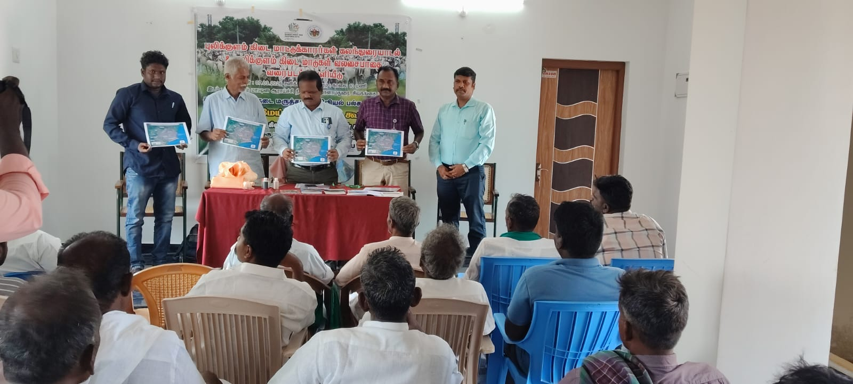
Dr. M. Murugan, Director, Centre for Animal Production Studies, Tamil Nadu Veterinary and Animal Sciences University, Chennai was the chief guest and highlighted need for conservation of Pulikulam Cattle Breed and how this centre enable cattle herders to derive more income through training program being organised. Dr. V. Palanichamy, Pulikulam Cattle Research Station welcomed the participants. Mr. P. Vivekanandan, SEVA has briefed about his role in registering Pulikulam cattle breed during 2012 and also the importance of International Year of Rangeland and Pastoralists 2026 as an opportunity to empower pastoralists through their traditional livelihoods. Mr. C. Rajiv Gandhi, Tamil Nadu Federation of Pastoral Peoples Sangams told the need for forming association with cattle herders for claiming their traditional rights including grazing in the forest. He also told considerable number of Pulikulam cattle population in Ramnad district. There was release of seasonal migratory map of Pulikulam cattle pastoralists. Dr. K.Srinivasan, Pulikulam Cattle Research Station proposed vote of thanks.
In the afternoon session there was discussion with the herders on the modality of forming groups / association at district level. Mr. P. Vivekanandan facilitated the process and the following was the outcome :
- District level association will be promoted for Sivagangai district. Members meet thrice in a year during full moon day of Tamil month viz. Masi, Vaikasi, Avani. Members has to pay Rs. 500/- as entrance fee and quarterly subscription of Rs. 500/-. The office head quarters / meeting venue can be temporarily at Pulikulam Cattle Research Station, Manamadurai.
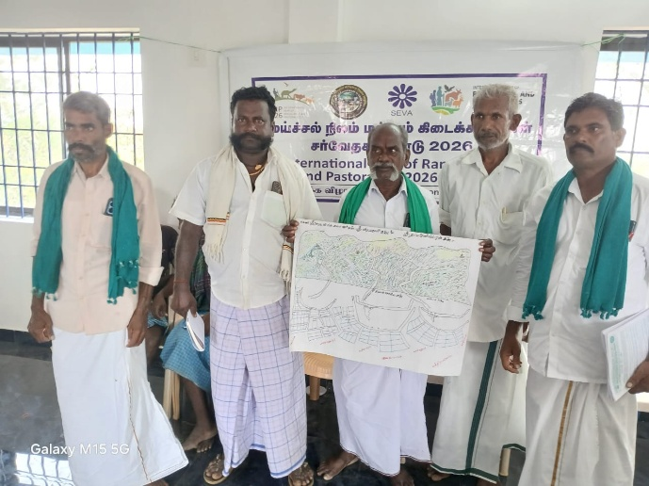 | 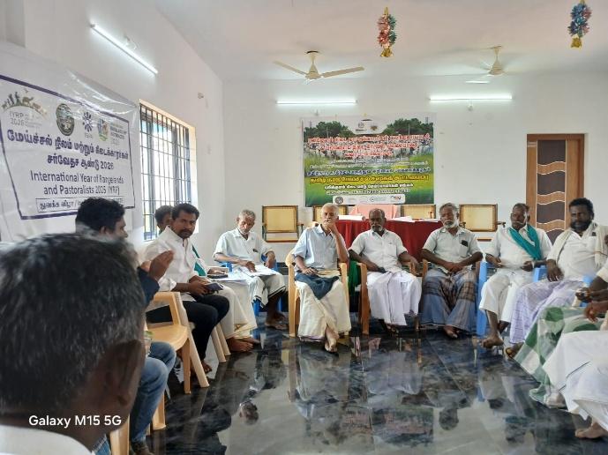
- Major disease of Pulikulam cattle are : Lumpy Skin Disease, Foot and Mouth disease and Karani disease. Karani disease will be noticed after the incidence of Foot and Mouth disease especially during summer season; if karani disease incidence is noticed during rainy season with few days of raining the disease will immediately will disappear. Farmers usually grind soaked fenugreek for administering it orally to reduce body heat of the animal as karani disease occurs due to increase in the body temperature.
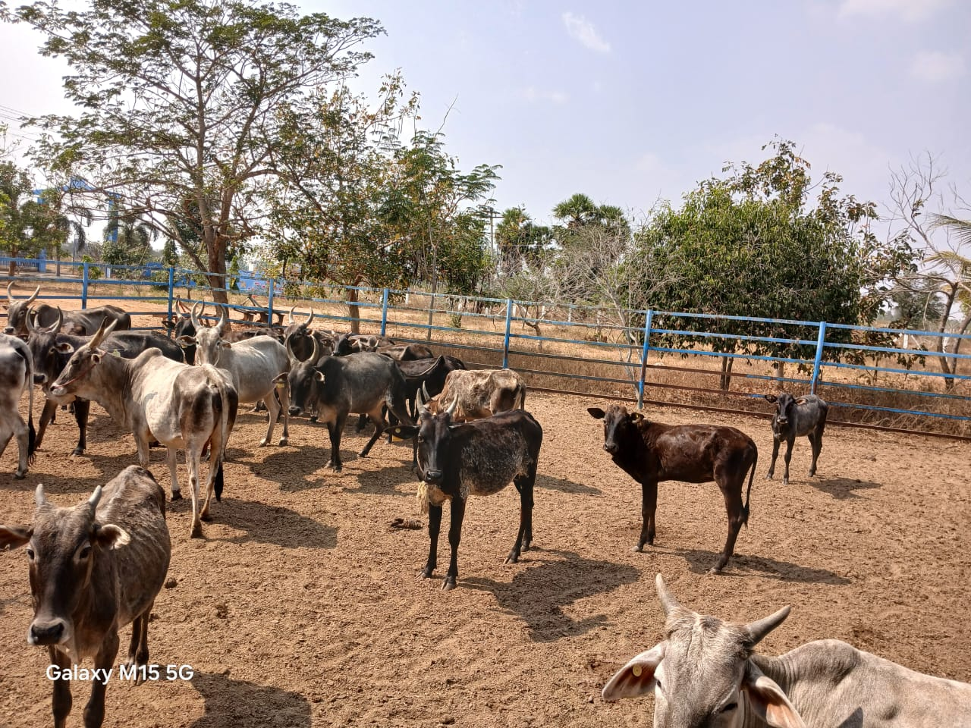
The picture shows karanai disease affected animal in the left side marked in a circle.
- Mr. Ramesh, a pastoralist from Velani shared his ethnoveterinary practices and he is able to cure all the disease of sheep using herbal preparations mainly with betel vine, pepper and salt. He admits that Valippu disease in sheep cause death of animal and herbal medicine is not effective.
- P. Vivekanandan, SEVA agreed to train selected youth on herbal treatment for livestock.
- Mr. Ramakrishan cattle herder in Manangathan village has presented draft map showing the migratory route in Virudhunagar distrct (Watrap block).
- Few issues have been identified to be taken up for redressal of grievances :
- Digging of water pond in Meenakshipuram village so that Vaigai river channel can be connected enabling drinking water source for cattle.
- The private encroachment in the revenue poramboku land in Kattikulam village is to be removed .
- Claiming rights as per Forest Rights Act 2006 is to be enabled for herders in Sivagangai district where eucalyptus plantation has been promoted by forest department.
- Smart card is to be issued to all the cattle pastoralists to prevent harassment or atrocities against migratory herders.
- Removal of Prosopis juliflora is to be undertaken in grazing lands; diverting pasture lands for other development purpose is to be stopped.
For more information contact :
Mr. Rajiv Gandhi, Tamil Nadu Federation of Pastoral Peoples Sangams
Cell : 9677517899

Minutes compiled by :
P. Vivekanandan, SEVA / IYRP - South Asia support group
8-3-2026

