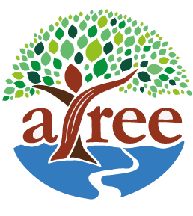
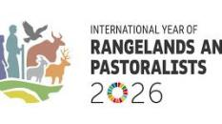
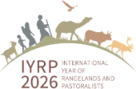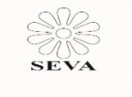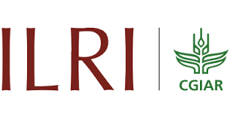
Side Event on - Rangeland Awards/ Champions 2026
Background
In association with ILRI we are planning to organise side event on " Rangeland Awards/ Champions and Best Practices of Community on Rangeland Management and Pastoralism".
During the side event we invite 2 members from the community to present their success cases and also showcase the profiles of 20 awardees.
Announcement of “Rangeland Awards” is to recognize the contribution of any individual or community or any group /association in rangeland restoration directly or indirectly in any part of the globe. It is being organized by IYRP Global and Regional Alliance groups in collaboration with many organizations including ILRI, UNCCD, WWF, FAO. Twenty awardees will be selected at global level and each awardee will be given 100 USD along with certificate. Profiles of awardees and along with their best practices/innovations will be made available for wider reach out during the side even of COP 17 of UNCCD at Ulaanbaatar, Mongolia on 17–28 August 2026.
Who can be nominated as a Rangelands Awards ?
Any individual or community groups who achieved in protection, restoration and management of rangelands viz. commons, water bodies, forests, grasslands / pastureland through practical actions on the ground either developing direct action or through policy or piece of legislation or advocacy by developing innovations and building capacity of communities etc.
Criteria for selection
Proven achievements in rangeland restoration by directly or indirectly in terms of land area covered, number of livestock and livestock keepers benefitted, details of biodiversity conservation, etc. through innovative practice, management, legislative, policy or community action.
What is the nomination process?
It is anticipated that Rangeland awardees will be nominated by applicant himself or any institutions/organization/Government agencies, etc. The call for nominations will be open
01 April 2026 onwards and it will be closed by 31 May 2026. The entries will be reviewed by a steering committee and result will be announced during the time of COP 17 of UNCCD side event during Aug 2026. The entries should be submitted only in the ‘Model proforma’ format enclosed. The last date for receipt of the completed applications is 31 May 2026.
Steering Committee members:
It includes 6 members representatives from national and international organizations including FAO, ILRI, IYRP Regional Support Group experts.

Model Performa for Applying Rangeland Awards
(Self-nominated /Nominated by others)
1. Name of Nominee along with his/her photo:
2. Address:
3. Phone and E-mail:
4. Brief background Information of Nominee including age, education and employment/profession associated etc. :
5. Challenges & Problems faced in Rangeland and Pastoralism in your area/region:
6. Describe Role and Achievements in Rangeland management/ restoration ( 2 pages) :
- The narrative shall include local name and type of pastureland/grassland and its legal status, Area of Land Involved and location, Number of livestock/ animal population benefited both wild and domesticated, Number of community members benefited, rules in management of resources , Any policy changes brought/achieved, Any other impact.
7. Please mention feedback from community members/public
8. What are the future plans or opportunities for strengthening your work on rangeland restoration and pastoralism:
9. Please add 4 - 5 pictures and one video clip ( 2 – 3 minutes) of your activities.

10. Reference of two known person/ leaders / Government. officials who are familiar about your work and achievements.

Signature of Nominee/ Nominator
For more Information contact :
P. Vivekanandan
SEVA
Chair- South Asia support group for IYRP
E-mail: vivekseva@gmail.com ​
www.iyrp.info

