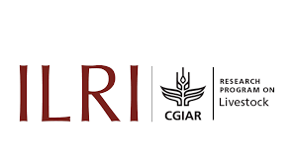

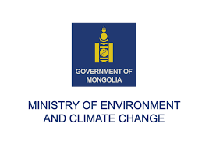


Lunch Dialogue:

Driving Policy Alignment and Action at UNCCD COP 17:

Advancing Integrated Land, Biodiversity, and Climate Outcomes for Rangeland and Grassland Resilience

Date: Wednesday, 9. December 2025
Time: 12:30 - 14:00
Venue: The luncheon will be held at the restaurant at UN Recreation Center, on the UN Campus, Nairobi, Kenya (directions to the venue can be found below)
Event description:
Rangelands and grasslands are among the world’s most critical ecosystems, supporting food security, livelihoods, biodiversity, and climate resilience for billions of people. The lunch dialogue aims to foster strategic alignment and catalyze cross-sectoral action, present the UNCCD COP 17 Rangeland Flagship Initiative, build bridges to the COP 30 Plans to Accelerate Solutions and to the UNEA Resolutions.
Yet these landscapes face growing pressures from land degradation, biodiversity loss, and climate change, while policy responses are often fragmented across sectors and institutions. As governments and stakeholders will gather at UNCCD COP 17 in August 2026, there is an unprecedented opportunity to advance integrated approaches that align land restoration, nature protection, and climate action, particularly in grassland ecosystems.
Convening leading experts, practitioners, and policymakers, the lunch dialogue will examine key challenges, highlight policy solutions, and identify practical pathways for scaling up impact. The dialogue will also serve to generate actionable recommendations and build momentum for synergy between the UNCCD, UNFCCC, and CBD frameworks, ensuring that rangeland and grassland resilience remains at the heart and present the latest information about UNCCD COP 17.

Objectives
- Showcase ongoing efforts to on alignment of biodiversity, climate and land agendas
- Inform about Mongolia Presidency program for UNCCD COP 17 and Rangeland Initiative
- Get support for wider recognition of grassland ecosystems and the crucial role that pastoralists play in safeguarding biodiversity.

Speakers:
Key notes: (each 5 min)
- Batbaatar Bat, Minister of Environment and Climate Change (keynote and opening)
- Deborah Mlongo Barasa, Ministry of Climate Change & Forestry (
- Rajeb Boulharouf, UNCCD
Inputs: (each 2 min)
- Lifeng Li, FAO Director Land & Water Division
- Cargele Masso Director, Impact platform on environmental health and biodiversity CGIAR
- N.N. Uruguay
- N.N. BMUKN (check Oliver Conz or Eva Kracht)
- Leigh Winowiecki, CIFOR-ICRAF
- N.N. GEF/GCF
- UNEP Abdelkader Bensada
- N.N. ILC
- N.N. CBD
Moderation WWF

Followed by a tour around the table.

Logistics
- The luncheon will be held at the restaurant at UN Recreation Center, on the UN Campus
  - Directions to the venue are:
    - From the UNEA-6 Workshop rooms, walk along the avenue of flags toward the exit of the UN Campus
    - Before you reach the exit, cross the internal UN road onto the footpath path to the UN Recreation Center, there will be signs for the River Cafe Upper Deck Restaurant
    - Please arrive ahead of the start of the event.
    - Vegetarian lunch will be provided.
    - See map below

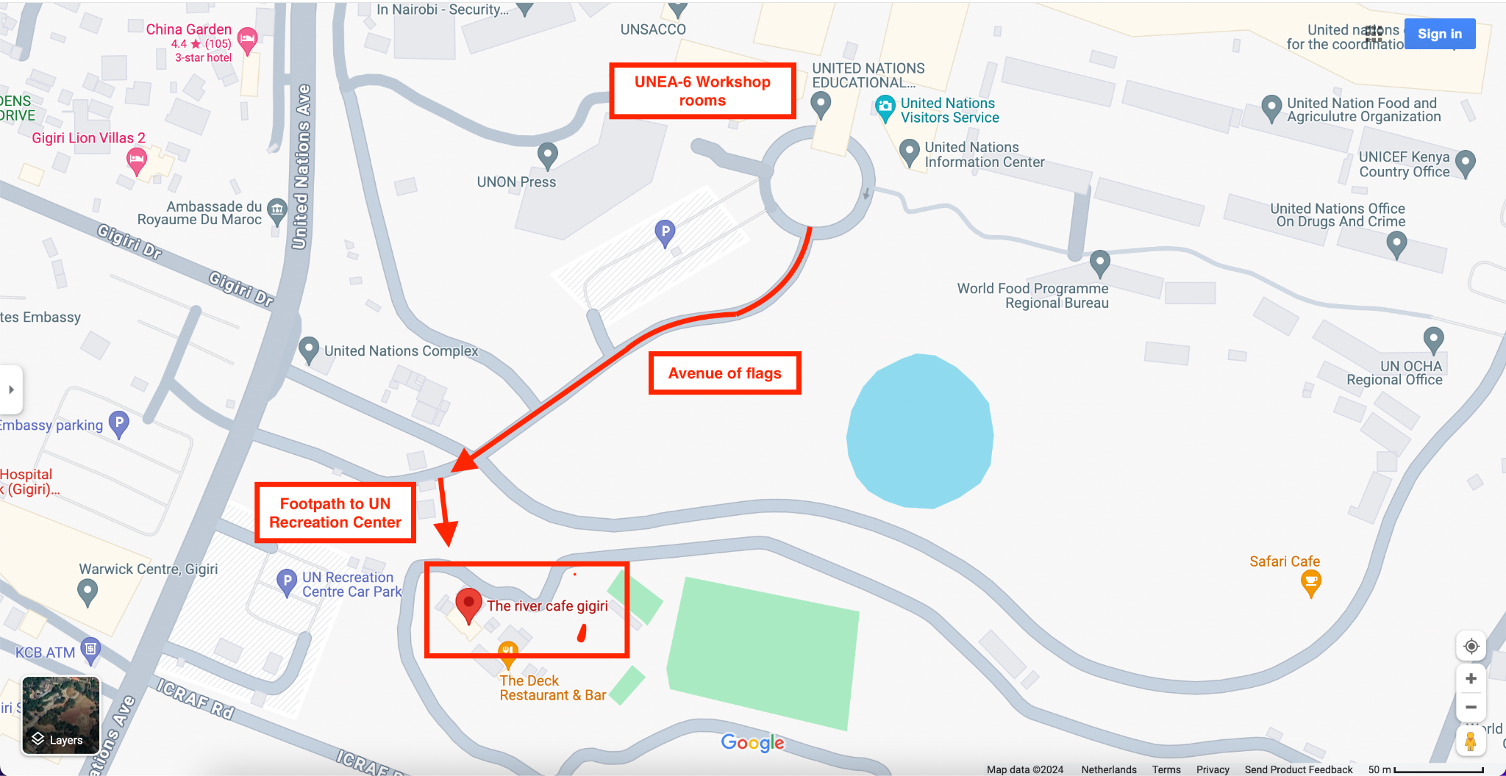

- Vegetarian lunch will be provided.

Contacts
- Martina Fleckenstein, WWF International, mfleckenstein@wwfint.org

