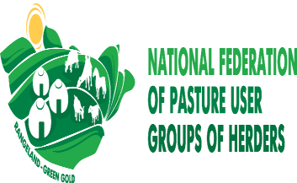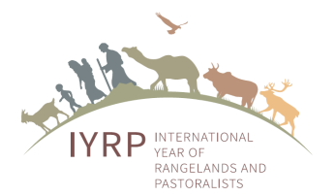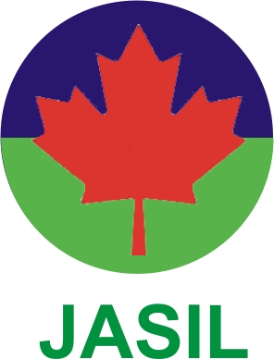

Award for Sustainable Pasture Management and for Conserving Rangelands 2021

Criteria for selection:
- The Awards for “Sustainable Pasture Management and for Conserving Rangelands 2021” is being organized by the National Federation of Pasture User Groups of Mongolia (NFPUG), Environment and Development Association JASIL, Ministry of Food, Agriculture and Light Industry, Mongolia (MoFALI), Central Asia Pastoral Alliance (CAPA), Central Asia & Mongolia Regional IYRP Support Group (CAM RISG) and the Mongolian Working Group (WG) on “Territories of Life” for Natural Resource Management (NRM) Communities, Pasture User Groups (PUGs) and Forest User Groups (FUGs) balancing ecological capacity of pasture with animal numbers and sound use of the rangelands they are using.
  - The award procedure will be announced in July 2021 during the Asia Grassland Workshop of the ICCA Consortium and will be published on the JASIL, NFPUG and MoFALI websites at the following links: http://cbnrm.mn , www.greenmongolia.mn , as well as in the “Ecological Capacity” newspaper of JASIL.
  - The final announcement of selection of award winners will be made in mid-September 2021 during a side event at the UNGA (United Nations General Assembly) for approval of the Mongolian proposal for an IYRP.
  - The merit of each pastoralist communities is sustainable and participatory management of rangeland territories to increase income from use of rangelands, with strong regulation and adjustment of herd size according to the ecological capacity of rangelands, producing value-added products and traditional food items, and using the environmental services provided by rangelands.
  - A prize of 1,450,000 MNT (500 USD) and Certificate will be given. The award function is tentatively proposed to be convened online because of the COVID-19 situation.

Last date for submission:
The local communities, PUGs and FUGs should submit their applications using the format given below.
The deadline for receipt of completed applications is 30 August 2021.

Selection Committee:
  - A 5-member selection committee will include one official nominee from JASIL, NFPUG, MoFALI, CAM RISG and Mongolian WG for Territories of Life. The decision of the selection committee will be final and binding.
  - Verification of claims will be undertaken for selected cases, if needed, with the help of a few independent experts / scientists from universities.

Format for submitting the community application
- Name of Pasture User Group (PUG), Forest User Group (FUG), NRM Community (Please attach a passport size photo of Community leader)
- Full address: aimak, soum, khoroo, bag, geographical location
- Contact Phone, Mobile, Identity Registration No. & Email address, if applicable
- Information on community members, total area of pasture/ forest/ NRM land, number of animals (males, females, young stock etc) of the community, PUG, FUGs.
(Detailed one-page information should be provided in a separate sheet.)
- Pasture capacity adjustment activities, mobility and pasture shifting and rotation activities, etc. and animal restocking activities, breed conservation.
- Details of conservation of rangelands including the area of regenerated and restored pasture land
- Production, labeling and marketing of community-made food products, activities to increase income and alternative income-generation activities
- Detailed 1–2 pages of information should be provided separately, together with a few good-quality photographs of the livestock, pasture capacity, biodiversity conservation, livelihood improvement actions etc.
Name & signature of person who prepared the application / community leader

Addresses for submission of applications:
or submission of Applications and further queries :

1. Hijaba Ykhanbai, JASIL

Mobile: (+976) 99282205

E-mail: jasil_ngo05@yahoo.com

2.Gankhuag Nyam-Ochir, NFPUG

Mobile: (+976) 9811 3747

E-mail: info@greenmongolia.mn

