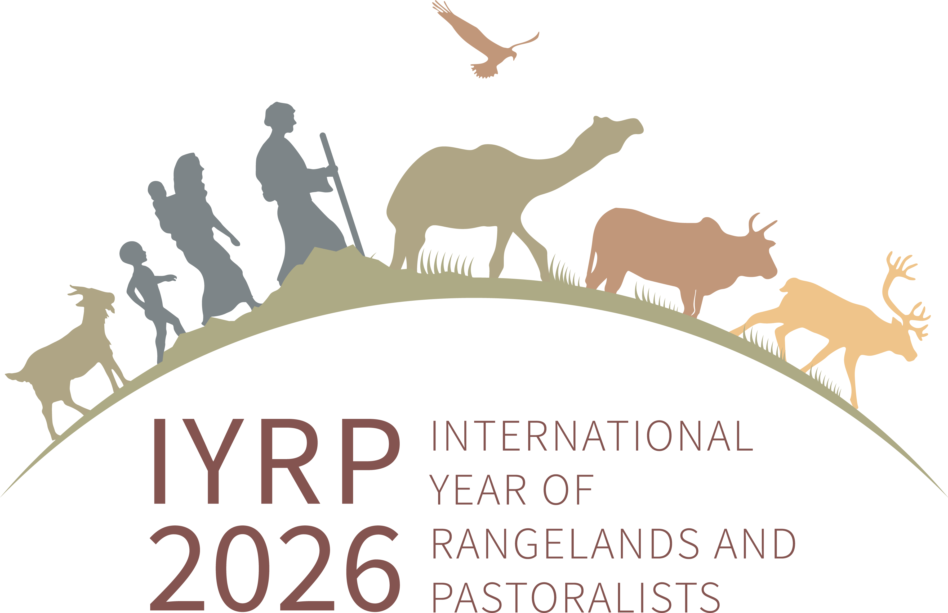

Brief for IYRP Working Group on Afforestation in Rangelands

We are increasingly concerned that rangelands, including grasslands and savannahs, are being targeted for massive tree planting efforts such as the Bonn Challenge in line with government pledges to combat climate change. Many of these policies very likely might have a negative impact on these ecosystems. The root causes are many but the IYRP aims at addressing at least one of them: the historical and current under-valuation of rangelands and misunderstanding of the benefits to pastoralists, society at large, ecosystems and the planet from maintaining healthy and sustainable rangelands. Trees and grasses do co-exist, but indiscriminate tree planting in grassy ecosystems will take us back decades and reverse gains in regeneration and rehabilitation of rangelands.
Several of you provided significant insights last year through an impromptu email exchange on the IYRP ISG network after seeing the government pledges following COP 26. Several of you are pastoralists who have faced this challenge first hand. Many of you have been raising the alarm about this issue for quite some time now. And many of you have collected data, created brilliant communication materials, talked at conferences, and influenced minds through your work.
We in the IYRP Global Coordinating Group feel that we could gain much more momentum and impact if we collaborated together. We, therefore, propose to establish an IYRP Working Group on Afforestation in Rangelands. We invite you to be part of this effort.
The aim of this Group would be to strategize on the right messages informed by evidence, the right audience, and the right avenue for disseminating our messages in the years leading up to IYRP 2026 – for example in the COPs of the climate change, biodiversity and desertification conventions; in events related to the UN Decade for Ecosystem Restoration; at the UN Forum on Forests; etc. Once such a strategy is developed, we can then work with the IYRP ISG network (306 organizations now) to disseminate them. Our indicator of success would be the number of national or global policies that are revised in recognition of the value of rangelands as ecosystems and to pastoralists.
The Group would:
- Prepare a concise and state-of-the-science evidence-based paper(s) that provide the statistical evidence, the case studies and best practices to pin our messages on, and
- Prepare the key messages and the contours of a global campaign, including for example identification of spokespersons and ‘ambassadors’, such as pastoralist representatives, world-renowned scientists, leaders of civil society, and of course government decision-makers.

We therefore would like to invite you to a first meeting of this Group so that together we can agree on its full scope and objectives, discuss the best ways to go about it, etc. It would be the launch of this Working Group.
The WG was launched on 20 July 2022.

All publications that this Working Group is using can be found here: https://www.ksfire.org/woody_encroachment/index.html

