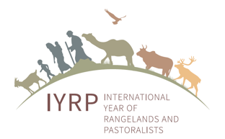
Mobile pastoralism valuing rangeland variability: a game-changing idea for sustainable consumption and production from the livestock sector
UNFSS Pre-Summit Parallel Affiliated Session, 26 July 2021
Table of contents
Introduction 2
Opening video “Pastoralism is the future” 2
Welcome by Jürgen Hoth, FUNBA 2
Opening remarks by Antonio Rota, IFAD 2
Opening remarks by Jonathan Davies, IUCN 3
Theme 1: Pastoralists and healthy rangelands 4
Carlos Martorell, UNAM, Healthy rangelands 4
Fiona Flintan, ILRI, Global Rangeland Atlas 5
Engin Yilmaz, Yolda Initiative, Pastoral mobility favouring biodiversity 6
Theme 2: Importance of mobility of livestock 7
Ian Scoones, PASTRES/IDS, Pastoralism, Uncertainty, Resilience: New science of variability 7
Hijaba Ykhanbai, JASIL Mongolia, Strength of local knowledge of Mongolian pastoralists 7
Ken Otieno, RECONCILE, Kenya, Participatory rangeland management in Kenya and Tanzania 8
Theme 3: Food production and consumption 9
Ilse Köhler-Rollefsen, Camel Charisma, India, Sustainable food production from livestock 9
Sarah Frazee, Meat Naturally, South Africa, Opportunities for value-chain approaches for sustainable pastoral production in South Africa 10
Pablo Manzano, University of Helsinki, Finland, Sustainable consumption of pastoral products 11
Theme 4: Policies and initiatives that support mobile pastoralism 11
Damdindorj Batmunkh, Government of Mongolia Government support to mobile pastoralism 11
Concha Salguero, Trashumancia y Naturaleza, Spain Mobile pastoralism in Spain 12
Igshaan Samuels, Agricultural Research Council (ARC), South Africa, Mobile pastoralism in South Africa 13
Summary, discussion and conclusion by Maryam Niamir-Fuller, IYRP 13
Q&A moderated by Ann Waters-Bayer, CELEP, and Cynthia Mugo, ILRI 14
Comments, questions and answers in Chat box 15
Conclusion by Maryam Niamir-Fuller 17
Closing film: Pastoralism: a sustainable and nature-positive production system 17
Annex 1: Biosketches of speakers and organisers 18

Introduction

Opening video “Pastoralism is the future”
Pastoralism is the future
Man-made climate change is creating conditions on our planet that are increasingly characterised by variability and unpredictability. Pastoralists use variability to their advantage. Their production systems guide us to a sustainable future. Find out how they do it here. MISEREOR supports the International Year of Rangelands & Pastoralists. The video was created by Cartoonbase and realised by CELEP, Vétérinaires Sans Frontières Belgium, MISEREOR Association of German Dioceses and the Belgian Government.

Welcome by Jürgen Hoth, FUNBA
We hope you enjoyed this film, which serves as a good introduction for this session.
Welcome to the UN Food Systems pre-Summit with the session “Mobile pastoralism valuing rangeland variability: a game-changing idea for sustainable consumption & production from the livestock sector”.
Together with you, we aim to convince the UN Food Systems Summit to adopt this global initiative.
We will make our case through four themes: the first, by presenting how pastoralists do sustain healthy rangelands; the second is about the crucial role of mobility of livestock; the third theme is on food consumption and production and the importance of our choices as consumers; and last, we will show policies and initiatives that support mobile pastoralism.
We will have three presenters per theme.
As we proceed with the presentations, we will place in the Chat the bios of each speaker. At any time, please feel free to also use the Chat to pose your questions, which the speakers will address in writing.
Towards the end, we will highlight some of your key questions, and we will carry out a poll to inform the UN Food Systems Summit about your thoughts on mobile pastoralism, followed by a beautiful video on pastoralists in Italy.

Opening remarks by Antonio Rota, IFAD
A very good day to all of you and welcome to this event. It is my pleasure to represent the International Fund for Agricultural Development, which, together with the International Livestock Research Institute, is hosting this event in support of the organising leaders FUNBA and RECONCILE.
Today, we will hear from representatives of millions of pastoralists from around the world. It is vital that we amplify their voices as we work to make food systems more equitable and sustainable.
Pastoralists care for their herds in some of the most remote parts of the globe. They have guided their animals to pasturelands, watering points and markets for thousands of years, generation after generation – through good times and bad. Always facing variable weather, they are now faced with global pandemics, wars and political turmoil.
But, through all of this, they have persevered. The products and services they provide are essential.
The organisations represented at this event will discuss issues of great importance to pastoral communities. This includes:
Firstly, how to maintain or even increase mobility through rangelands to protect ecological resources.
Second, how to ensure production is sustainable.
Third, ways to preserve cultural values, livelihoods and economic wellbeing.
And, fourth, maintaining secure access to natural resources.
We are working with all our might to have pastoralists recognised as “stewards of rangeland ecosystems” and to declare 2026 as the International Year of Rangelands & Pastoralists (IYRP).
We aim to raise global awareness and prompt concrete and sustainable actions. And we will highlight the need to improve the livelihoods and living conditions of pastoralists by providing greater access to education and learning and better health services – and by drawing attention to the needs of pastoral women and rural youth.
The mandate of the International Fund for Agricultural Development is to reduce rural poverty and hunger, leaving no one behind. Since our inception more than 40 years ago, we have continuously engaged in pastoral areas and supported pastoralists, small-scale producers and other rural people who are at the very heart of food systems. We look forward to working with everyone here today to achieve the Sustainable Development Goals through the game-changing Idea being discussed today to achieve rural transformation.

Opening remarks by Jonathan Davies, IUCN
It is a pleasure to speak today on behalf of the International Union for Conservation of Nature IUCN). As a union of state and non-state actors working on conservation and the transition to sustainable development, IUCN has a keen interest in rangelands and grasslands.
Thanks to the recently published Rangelands Atlas, we now know these lands occupy more than half of all land on earth.
They support the livelihoods of millions of pastoralists, while at the same time they provide habitat for an extraordinary array of biodiversity.
In fact, the ecosystem services of rangelands benefit billions of people – including provision of clean water, climate change mitigation, and supply of high-quality animal protein.
In many of the most food-insecure and nutrient-deficient countries, the majority of protein is supplied by livestock from the rangelands.
The producers of this livestock, and the stewards of these valuable lands, are of course pastoralists. They manage one of the most environmentally friendly food production systems, but in many countries, their capacity to manage rangelands sustainably has been undermined by constraints to their rights and their livelihoods.
Pastoralism, with its organised herd movements and communal resource management practices, is an adaptation to the extreme variability of the rangelands. The tragedy of the rangelands is that variability, and pastoral adaptation to it, are poorly understood, and this has led to policies and investments that undermine this adaptation.
This has weakened pastoral livelihoods and has led to degradation of rangelands in many countries. It is only possible to sustainably increase food productivity in the rangelands if pastoralism is recognised, pastoralist knowledge is enabled, pastoral resource rights are secured, and degraded rangelands are rehabilitated.
This is why valuing variability is a game-changing idea for sustainable consumption and production in the livestock sector, as we will hear from the speakers at today’s event.

Theme 1: Pastoralists and healthy rangelands

Carlos Martorell, UNAM, Healthy rangelands
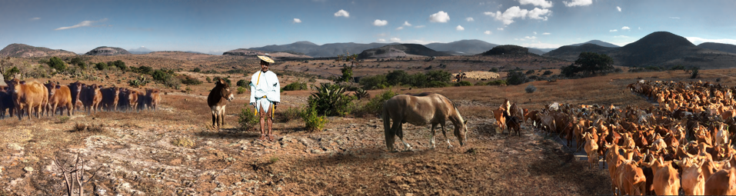
Credit: Aslam Narváez
Rangelands and grasslands are frequently seen as valueless results of destruction caused by people and livestock. This has been the case in a seemingly barren site in southern Mexico, which nevertheless harbours at least 600 plant species. It is a hotspot within a hotspot: the world-heritage Tehuacán Biosphere Reserve. In a tiny 10x10 cm², up to 25 plant species can grow – this is a world record. In fact, the only system other than tropical rainforests that holds plant diversity records is rangelands.
In Brazil, the tiny campo rupestre grasslands harbour nearly 20% of the country’s plant diversity. The rangelands of the Cape region are the most diverse ecosystem outside of the tropics. These examples are the tip of the iceberg. Worldwide, more plant species grow in grasslands than in rainforests, and their fauna is one of the most diverse and charismatic.
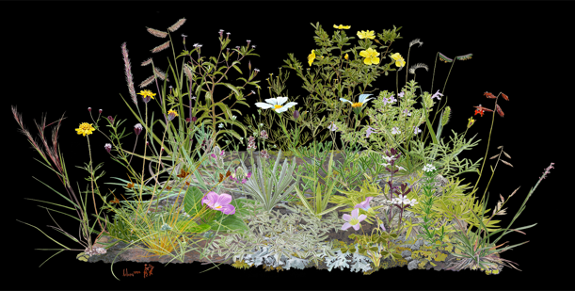
Credit: Aslam Narváez
Much of that fauna has been lost. Returning to the Mexican case, horses, camels, bison, donkeys, mammoths and many other grazers roamed here. With the arrival of European livestock, large herbivores fed in these grasslands again, restoring their natural dynamics. Plant diversity is currently enhanced by livestock, which controls competitive herbs that would displace their neighbours. Three micro-endemic plants, which evolved here in the presence of large herbivores, tolerate or even benefit from livestock.
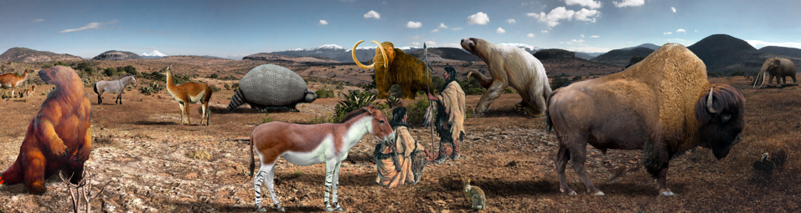
Credit: Aslam Narváez
Worldwide, appropriate livestock management is key to maintain the diversity of grasslands or even grasslands themselves. The extremely diverse European grasslands would have disappeared altogether with the Quaternary megafauna, had it not been for the arrival of pastoralists.
Rangelands also provide important ecosystem services. Nearly as much carbon is stored in grassland soils as in forests. Due to its lighter colour, grass reflects more sunlight than trees, cooling the planet. Grasslands produce more water than afforested areas.
Livestock enhances some of these services, such as the rate of carbon sequestration. As Ian Scoones will show, many of the problems associated with livestock are solved when animal mobility is granted. Nevertheless, general disdain for rangelands is rapidly destroying both nature and traditional livelihoods. Afforestation threatens 10 million km² of grasslands worldwide. Due to expansion of cropping, North American grasslands and the hyperdiverse African renosterveld are among the most endangered ecosystems worldwide. Pastoralism preserves these biological jewels.
It is just as irrational to fell a forest to bring in artificial pasture and cattle, as it is to expel livestock from diverse rangelands and plant artificial forests.

Fiona Flintan, ILRI, Global Rangeland Atlas
The recently launched Global Rangelands Atlas highlights the need for mobility as part of the pastoral system and in order to keep rangelands healthy. The Atlas developed from the combination of large data sets layered on a base map of “rangeland” biomes as defined by WWF is a starting point from which to dig deeper in order to understand the current status of rangelands, trends occurring and forecasts being predicted. Not least, the Atlas has been able to confirm that – broadly speaking – rangelands cover 54% of the world’s terrestrial surface.
The Atlas not only brings big data together, but it has also provided a space for local voices to come forward, through local case studies accompanying each map and short films from local protagonists telling their stories – whether from Spain, Tunisia, Tanzania or elsewhere.
The Atlas is the first step in developing a global rangelands data platform that we hope will help to fill in some of the data gaps highlighted by other speakers. The data platform will both bring together data that already exists and source new data through remote sensing or other, including through crowd-sourcing. We anticipate it will be a multi-stakeholder initiative serving different needs and priorities. It will be a key source of data as we move forward to the IYRP. The platform is still under design but, in the meantime, please visit the Atlas website at: www.rangelandsdata.org/atlas
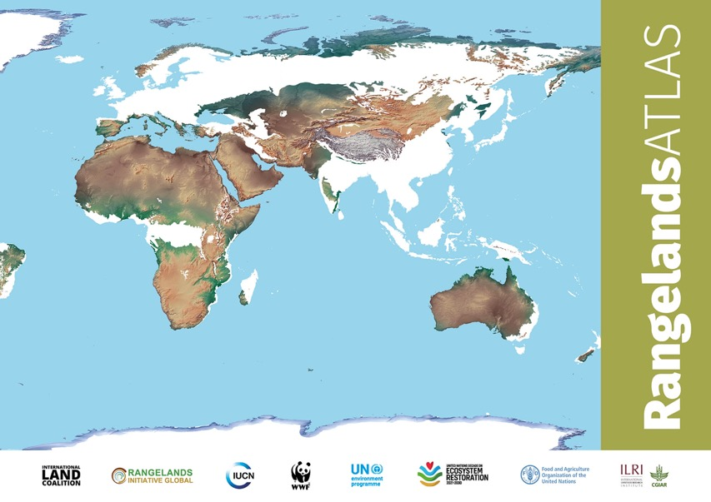

Engin Yilmaz, Yolda Initiative, Pastoral mobility favouring biodiversity
The strong linkage between the maintenance of mobile pastoralism and biodiversity conservation has been supported by a growing body of evidence.
Mobile pastoralists have been a major agent particularly in the evolution of rangeland ecosystems for thousands of years. It is especially their mobility that has allowed them to access and conserve forage and water resources that are unevenly distributed and vary over time.
Their systematically managed movements are analogous in spatial and temporal scales to wild herbivore species’ movements and they have very similar effects on ecosystems, yet driven by land-management choices of mobile pastoralists.
As is the case with wild herbivores, mobile pastoralists’ livestock exerts numerous effects on plant communities and ecosystems. Among them, a major beneficial effect is the generation of spatial heterogeneity.
Being central to the process of patch dynamics, the movement of livestock between different patches allows vegetation in previously visited patches to regenerate and to recover and so creates a shifting mosaic of patches.
This spatial heterogeneity with diverse plant species promotes diversity of species of different taxonomic groups by increasing available niche space and thus allowing more species to co-exist. Evidence shows that undergrazing of rangelands is just as bad as overgrazing for rangeland health.
One other major effect involving movement is related to the role of livestock in the dispersal of plants by epizoochory (the transportation of seeds attached to animal coats or hooves) and endozoochory (dispersal by ingestion and later defecation). Seeds attached to the fleece of livestock can be transported distances of up to several hundred kilometres in substantial numbers.
Livestock movement also plays an important role in soil nutrient cycling, contributing to nutrition transfer across the landscape. Mineralisation of organic matter in rangeland ecosystems is to a large extent done by bacteria in the dung that dung beetles, ants and termites further help to incorporate into the soil.
Livestock migration routes function as ecological corridors and are central to the structure and functioning of ecosystems and the ecological integrity of landscapes, and therefore for avoiding the isolation and fragmentation of landscapes. In many cases, the landscapes that are so coveted by conservationists have been created and maintained over centuries by the presence and movement of mobile pastoralists and their domesticated herbivores.
We must recognise the long-standing role of mobile pastoralists in the maintenance of the world’s rangelands. Rangelands are one of the most imperilled and the least protected ecosystems on earth, vastly under-represented in the world’s protected area system. It is imperative that we conserve mobile pastoralism as a nature-based production system due to its many benefits for rangeland ecosystems and so for biodiversity as well.

Theme 2: Importance of mobility of livestock

Ian Scoones, PASTRES/IDS, Pastoralism, Uncertainty, Resilience: New science of variability
There is an urgent need for a new science of variability in agriculture and food systems, which is rooted in mobility and flexibility and centred on pastoralists’ own knowledge.
In discussions around the UN Food Systems Summit so far, there is much emphasis on so-called ‘science’ – but what science, for whom? Is the Green Revolution (GR) science of crops, fields and plots appropriate to the highly variable rangelands where the world’s pastoralists live? I’d say no. Instead, a new science of variability – based on what we call non-equilibrium thinking – has major implications for how we think about livestock-based food systems.
I want to focus on just two themes: production and environment:
First, take production. There is much debate about improving livestock systems, but this largely focuses on control, containment, intensification and management through a particular type of science. Yet pastoralists make use of variability as a productive resource through moving to exploit rangelands, supported by careful herding and animal breeding. It is clear that producing diverse livestock products in areas where conventional systems cannot work, alternative approaches are needed to support mobility, flexibility and responses to variable and uncertain conditions. And all this is made even more important by climate change.
Second, take the environment. Again, much of the debate misses an understanding of variability. Rather than causing degradation and desertification, in such variable ecologies, mobile pastoralism can improve the environment, enhance biodiversity and reduce climate impacts. As a report that we will be releasing later this year highlights, too often environmental and climate assessments ignore the variable contexts within which pastoralists live, suggesting inappropriate solutions that may actually make matters worse.
A new science of variability that takes account of pastoralists’ knowledges, practices and contexts is an important way forward. We have missed this in the debates about food systems to date – the GR model of agricultural science focused on stability and control is simply not appropriate for increasing production, improving environments and confronting climate change in pastoral areas.
A paradigm shift is urgently needed. And importantly, we can learn a lot from mobile pastoralists making a living around the world, often in very harsh settings – whether in the steppes of Mongolia or the drylands of East Africa, which we will hear about in a moment.

Hijaba Ykhanbai, JASIL Mongolia, Strength of local knowledge of Mongolian pastoralists
Mongolian herders have traditional ecological knowledge transferred to them from generation to generation. Pastoral agriculture is a way of life for the local communities of Mongolian herders. They produce many types of food products that are very important for food security at national and local level, and they are also custodians of environmental protection. Our livelihood depends on the sound use of pasture and rangelands.
Rangeland management depends on climatic variation and vegetation, natural disasters, such as droughts, cold winters, dust and sand storms, and the scarcity of pastureland with an increasing numbers of animals. It also includes complex issues with many stakeholders, such as herders, their communities, neighbouring herders, outsiders, incomers from other regions, nature conservation activities, medical plant collection, hunting, mining, forestry and many infrastructural and economic projects. Therefore, it needs participatory management involving all these stakeholders and local governments.
Currently in Mongolia, there are 1705 organised Pasture User Groups (PUGs) involving more than 90,000 herder families that operate on a total of about 30 million hectares of rangeland. The purposes of the PUGs are to co-manage rangelands and to clarify pasture-use rights of herder families through land-use agreements and monitoring activities together with local government authorities. They try to do this in a way that includes all social groups, such as poorer herders, marginalised communities, women and youth.
Also, about 1000 forest-user groups have contracts with local governments for the allocation of rangelands and forests to these communities.
Mobility is the most effective strategy in pastoral agriculture. Herders practise pasture shifting and rotation on a seasonal basis, from winter pasture to spring pasture, from spring to summer pasture, from summer to autumn pasture, and back from autumn pasture to winter pasture. Mobility in pastoralism greatly supports restoration and natural regeneration of the rangelands. Therefore, mobility is most important for rangeland management and the livelihoods of local communities.
However, in addition to these achievements, there is a need to legalise traditional pasture-use rights of herders and officially recognise herders as food producers and custodians of the environment and nature protection.
Pre-recorded video of Hijaba Ykhanbai’s presentation: https://www.youtube.com/watch?v=7zu80ZsAfIY

Ken Otieno, RECONCILE, Kenya, Participatory rangeland management in Kenya and Tanzania
Sub-Saharan Africa is predominantly composed of rangelands being two thirds, consisting of arid and semi-arid grasslands, woodlands, savannahs, shrublands and deserts. They also provide the basis for the livelihoods of millions of pastoralists, agropastoralists and farmers – through rearing livestock in mobile or sedentary livestock systems, or through farming crops in mixed livestock-cropping systems.
Recognising the importance of rangelands and pastoralism as an integrated livelihoods system, participatory rangeland management (PRM) has proved to be a tool for ecosystem restoration and food security for rangelands users. The case in East Africa – an upscale of the concept in Ethiopia – has demonstrated practical results in both Kenya and Tanzania.
- Restoring rangelands and protecting critical rangelands resources
- As a participatory tool for community-level engagement
- Policy recognition and integration of PRM in Kenya in County spatial planning and community land registration http://www.landcommission.go.ke/article/county-spatial-planning-in-pastoral-areas-annex-to-cspmonitoring-and-oversight-guidelines
There are various environmental and socio-cultural functions that rangelands also fulfil but governments often do not include in development plans. This makes rangelands more susceptible to climate change, conflict and degradation. PRM has emerged as an integrated approach building resilience among resource-dependent communities, promoting sustainable livelihoods, and creating local-level incentives and value chains – as a tool distinguishing attributes of the issues, e.g. land natural resources, attributes of the actors involved, and governance arrangements especially in building sustainable food security.
PRM aligns with and has the potential to contribute significantly to the UNFSS and the game-changer idea building blocks from the community-level food systems to the global policy agenda for ecosystem restoration.

Theme 3: Food production and consumption

Ilse Köhler-Rollefsen, Camel Charisma, India, Sustainable food production from livestock
We just have heard a lot about the environmental benefits of pastoralism and about the ecological need for grazing animals in landscapes. But pastoralism also produces an amazing amount of food and makes major contributions to the Gross Domestic Product (GDP), especially in African countries where it contributes 10–44% of the GDP and 70–80% of the agricultural GDP in Sudan and Mauretania. And in a country like India, around 70% of the meat and more than 50% of the milk derive from agro-pastoral systems.
Most amazingly, this food is produced without fossil fuels and any chemical inputs in a completely natural way with herd animals converting biodiverse biomass into protein.
Thus, the world’s pastoralists exemplify nature-positive production at its best and, if we want to support nature-positive production, we need to encourage and support these systems by allotting space for them and enabling the marketing of their products.
Because there is another important aspect to mobile livestock keeping that has implications for human diets and public health: due to the biodiversity of the forage plants eaten by moving livestock, pastorally produced food is very rich in micro-nutrients, providing nutrients that are absent from most modern diets, which depend on heavily fertilised, industrially produced plants.
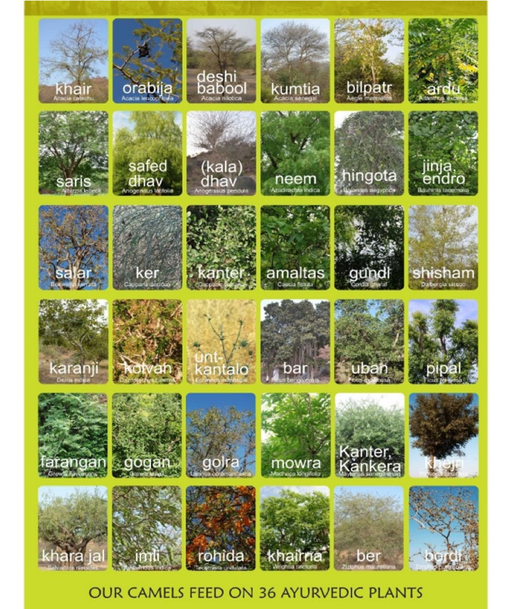
To illustrate this, I would like to show you the 36 medicinal or ayurvedic plants that the camels eat that supply the milk for my dairy in Rajasthan. Based on information provided by the herders, they forage on Acacia trees, thistles and vines, so their diets go much beyond the grass that most pastured animals eat. All these plants are also used in traditional medicine, and that’s why local people believe that milk from animals grazing on natural unfertilised forage are almost like therapy and keep you healthy. Where I work, even poor people prefer to spend more money on meat and dairy products that they know come from pastoralist systems rather than buy the cheaper industrial equivalent in a store.
That’s why we should aim for a label or certification for products from pastoralist systems.

Sarah Frazee, Meat Naturally, South Africa, Opportunities for value-chain approaches for sustainable pastoral production in South Africa
Ilse has shared the nutritional and food rationale for pastoralism, but consumers are not often able to obtain products from production in non-intensive range systems due to barriers to market entry in formal livestock product value-chains.
Most people are aware of industrial systems of meat production from feedlots, but even most extensively produced animals are based in a centralised collection and processing area that at best force those producers in remote or marginal lands to transport animals over large distances or, at worse, require record-keeping standards that do not enable mobile pastoralists without set land-tenure access. Such market barriers not only block huge development opportunities for rural poor; they also create perverse food systems that benefit a few rather than a majority. For example, in South Africa, 50% of the national herd exists as the primary livelihood source on lands held in collective traditional authority and 50% is held on private land-tenured lands. Yet, 95% of the formal market meat in the country comes from the private lands and South Africa actually imports 20% of its meat.
To enable pastoralists to maximise their contribution to sustainable food systems, the private sector can adopt new technologies that enable mobile market access, and governments should create an enabling environment that supports business players to do so. Some examples of technologies that can be considered:
- Use of virtual auction technology for livestock purchase
- Mobile auctions that bring buyers to pastoral groups
- Mobile abattoirs that allow a humane slaughter and delivery of meat rather than live animals for better quality end products.
And I am sure there are many more. The first challenge is to ensure national legislation can enable and not stifle such innovation as a result of entrenched business interests from industrial meat era and to allow technology to create new value chain opportunities for pastoral producers and those consumers looking for natural meat.

Pablo Manzano, University of Helsinki, Finland, Sustainable consumption of pastoral products
Pastoral products have nutritional qualities that are superior to other meat and dairy products and are healthier for the consumers. They display better fat profiles, namely more polyunsaturated fatty acids and better Omega 3/ Omega 6 ratios. Increasing evidence shows that they incorporate phytochemicals, which protect meat and dairy from protein oxidation and lipid peroxidation. Pastoral products offer a good alternative for environmentally concerned consumers.
However, most statistical data do not distinguish pastoralist systems from other livestock productive systems – an issue that has been flagged by the United Nations. National statistics agencies as well as international organisations such as FAO and ILRI need resources to develop livestock information systems, so that everyone can design adequate policies for the current development challenges. Establishing typologies of livestock systems is a necessary but complex task, because the different phases in the lifetime of a single animal often combine both grass-fed and confined stages.
Even where there are data, there are challenges in how metrics are used. A large greenhouse gas footprint is attributed to pastoralism, ignoring that emissions from pastoralist systems are part of the natural ecosystem fluxes due to their livestock’s similarity with wild herbivores. A large water footprint is attributed to pastoralism in the media, even if most of it consists of rainwater that has no impact on water scarcity. All of this reflects the inadequacy of Sustainable Development Goals (SDG) indicators for measuring some pastoralist strengths.
Consumers are faced with challenges when selecting pastoral products, because of this lack of information. Sometimes even traditional pastoralist specialties are produced from industrially raised animals, lowering the quality of the products. Clear labelling and product tracing are being demanded by today’s knowledgeable public.

Theme 4: Policies and initiatives that support mobile pastoralism

Damdindorj Batmunkh, Government of Mongolia Government support to mobile pastoralism
First of all, I would like to congratulate all of you participating in the UNFSS Pre-Summit Parallel Session and express my deepest appreciation to the team who is hosting this important conference virtually at this difficult time when every country is struggling with the pandemic.
All countries are working hard to overcome the pandemic with minimal damage on their economy, and to recover the post-pandemic economy in an environment-friendly manner and to fulfil its obligations to the international community.
Mongolia is a country with harsh climatic conditions and a long history and rich culture in livestock husbandry. Consequently, livestock husbandry is the most significant subsector that produces over 80% of total agricultural products which accounts for 20% of gross domestic production, around 9% of the country’s export income, directly employs 35% of total work force and contributes to alternative income generation of half of the country’s population.
Like other countries, we are also taking step-by-step measures to overcome the pandemic with minimal impact and to shift the economic recovery from the pandemic to a greener environment.
An example of this is the Government of Mongolia's long-term development policy of “preserving traditional nomadic heritage, ecologically friendly, sustainable and organic animal husbandry, and promoting nomadic animal heritage to the world” is reflected to its national programmes and government policy papers.
In addition, we are working to make this initiative a reality and its importance to declare the IYRP to promote pasture's contribution for global food security and ecosystem benefits, sustainable pastureland management and rehabilitation to increase investment and support sustainable development.
Currently, rangeland degradation has become a crucial environmental issue in Mongolia, with the area of degraded rangelands increasing owing to socio-economic and climate change occurring throughout the country.
An IYRP can provide the impetus and momentum necessary for a worldwide understanding of the importance of these lands to global food security and environmental services, and can also enhance governments’ awareness and capacities to deliver on the SDGs and other global development and environmental goals in such marginal areas. Pastoralists are explicitly recognised in the 2030 Agenda as a group of peoples who should benefit from achievement of the SDGs.
The Government of Mongolia has begun to develop an action plan for the implementation of this initiative in cooperation with relevant international organisations, and as the initiating country, a certain amount of financial support and funding will be approved in the budget law of Mongolia for the implementation.
We are confident that the IYRP will have a real result and positive impact on increasing the world's food supply, reducing hunger and poverty, and providing the world's population with high-quality and eco-friendly food by the sustainable use of pastureland.
Therefore, I urge you to support and cooperate with our country's initiative. Thank you for your attention and cooperation.

Concha Salguero, Trashumancia y Naturaleza, Spain Mobile pastoralism in Spain
Transhumance is the pastoral system that consists of the annual return movement of shepherds and livestock between lowland plains (in the winter) and mountains (in the summer) in search of available pastures following the natural seasonal cycle of vegetation growth and grazing. This is why transhumance is considered the most efficient pastoral system in terms of the use of natural resources and land management.
This ‘pendular’ movement is essential in areas of the planet with extreme weather variability such as the Mediterranean Basin, where Spain stands out as the most striking example of living transhumance in a Western country. Its 125,000 km of transhumant routes (or drovers’ roads) are ecological corridors along which millions of seeds and insects are carried and dispersed by the livestock. These ‘motorways of life’ interconnect valuable habitats, thus preventing their isolation and fragmentation. It is no accident that Spain is the richest country in Europe in terms of biodiversity, with the most extensive network of Natura 2000 sites, partly created by centuries of transhumant practice.
Transhumance also creates habitats for other key species (such as pollinators) and provides vital services for others (such as vultures, which is vitally important, as Spain hosts 95% of the European vulture population). The development of adapted local ‘native breeds’ and maintenance of the rural economy are other benefits provided.
For all these reasons Trashumancia y Naturaleza (TyN), the association I work for, has supported transhumance systems for the last 30 years. When we started, transhumance was neglected and perceived as an outdated system of no value; since then, TyN has supported more than 50 herder families and the number of livestock involved has increased. Today an estimated half a million animals do some kind of short- or long-distance transhumance in Spain, about a quarter of them on foot.
To lead by example, TyN drives every year its own herd of 1500 sheep and goats on a 500 km transhumant journey from the Picos de Europa Mountains to Madrid, including passing through the Madrid city centre.
In TyN, we believe that transhumance today is a key ‘retro-innovation’ tool for tackling the different crises which currently confront modern society: environmental, sanitary, and economic, which in essence have the same underlying causes.
Transhumance is a legacy from the Neolithic when humans were able to observe and learn from the great herbivore migrations. Since then, it has provided benefits for people and planet and has been improved, tried and tested on the ground during at least 7000 years. It is simply a system too vital to be lost now. The good news is that it is still alive and it is here to help.

Igshaan Samuels, Agricultural Research Council (ARC), South Africa, Mobile pastoralism in South Africa
South Africa has over 470 vegetation types and 23 000 plant species. This indicates a great diversity in forage for livestock across various spatial and temporal scales.
Our colonial- and apartheid-era policies have resulted in a dual agricultural system with a highly commercialised and modernised sector and traditional farming largely practised at small-scale and subsistence levels.
Traditional mobile pastoralists resisted sedentarisation throughout our recent history and continued herd mobility even though most of their lands were privatised. They now practise short-range mobility but the highly heterogeneous landscape and the different species and breeds they keep allow them to access a wide variety of resources even over short distances. They implement a daily grazing menu system similar to shepherds in Europe, where they herd their animals to specific parts of the rangeland based on animal behaviour and level of hunger.
Recently, some of these pastoralists have become innovative by redistributing the land allocated to them as part of the country’s land reform so as to be able to move their herds over larger areas.
Since commercial livestock farms are almost exclusively divided into fenced paddocks, which curtail mobility, recent management approaches adopted include the use of herders and removal of internal farm fences. Experimental farms for demonstration and herding academies have been established to train commercial ranchers and professionalise herding. A few commercial farmers have now adopted herding and herd mobility as their main grazing management approach.
On a larger spatial scale, private ranchers often negotiate and make agreements with other ranchers sometimes more than 1000 km away and move their animals there to escape drought. A recent study on 100 of the best extensive livestock farmers in the country shows that this was one of the key management practices to survive the recent drought, which was the worst in the last 100 years.
While pastoralists have become innovative in implementing different forms of herd mobility, our policies are still not supportive of mobile pastoralism. South African policies affecting pastoralists and rangelands should be harmonised with the realities on the ground.

Summary, discussion and conclusion by Maryam Niamir-Fuller, IYRP
Dear participants, you have heard and seen now, through the amazing expertise and experience of our speakers, how vast and diverse the rangeland and pastoral systems are, and the opportunities and challenges facing them. Our aim is to bring the many voices of pastoralists and those who support them to the attention of the Pre-Summit delegates. I personally call on you to take these views seriously – and listen to the counter-summit too. Remember, we are in the UN Decade on Family Farming. The UNFSS must recognise pastoralists’ rights.
I would like to leave you with four thoughts:
- Rangelands are vital ecosystems for food production, biodiversity conservation and climate-change mitigation. Conversion of rangelands to crops, feed or forest is not sustainable and should not be condoned.
- Through millennia of experience, pastoralists have learnt how to work with natural variability to secure their livelihoods. Mobility of their animals is a vital ingredient of that success and can help restore and ensure healthy rangelands.
- Sustainable production of nature-based meat and milk is not only possible but desirable because of the nutrient-dense food it provides. There are many ways to make it more commercially viable and increase incomes for pastoralists.
- We are already moving towards sustainable pastoral and rangeland systems, if only we were aware of it. Some governments and NGOs are showing the way; pastoralists themselves are innovating. The proposed IYRP will help raise this awareness.
I hope we have convinced you that the Game-Changing Solution that values rangeland variability and focuses on mobile pastoralism will accelerate this trend, and that is why we ask the UNFSS to adopt it.
What do you say? Take the poll – tell us yes or no. “I agree, the Game-Changing Solution on Valuing Rangeland Variability: a global initiative for mobile pastoralism should be adopted by the UNFSS.”
Results of Gamer-Changer solution: 100% yes!

Q&A moderated by Ann Waters-Bayer, CELEP, and Cynthia Mugo, ILRI
People have been posing questions, and some speakers have been responding to the questions. The first question was on food safety, and there have already been a number of responses (see Chat box below), so we'll go over to a question that has not yet been answered:
What is the impact of conventional education systems and globalisation to the practice of pastoralism? How can we rope in pastoralists themselves in this campaign?
Pablo Manzano: I think the issue about education is very relevant because it guarantees the future of pastoralism, in a sense, by providing complementary livelihoods, but it really depends on how the education is delivered and, I would say, conventional education that implies sedentarisation of pastoralists has been one of the major destructive forces of mobile pastoralism, the most sustainable way of livestock-keeping. So I think we have to learn a lot still from some successful experiences, for example in Iran or even in Kenya, but probably we would need to expand the successful experiences of mobile schools in those countries. But I think it is time to reflect on expanding that to secondary education, because this is when we will start to produce professionals like doctors and lawyers and other types of professionals that do have a mobile life and that can accompany mobile communities. And, as we know, mobility is an absolutely key part of the sustainability element of pastoralism.
One big issue in Mexico is the loss of valuable genetic resources of native rangelands due to overgrazing. Action is required to protect rangelands in the north highlands of Mexico.
Jurgen Hoth: Based on the experience that Carlos showed us at the beginning, it depends on the system – a grassland system without grazing is a doomed system. Grazing and grasslands are one. And there is scientific evidence not only in Mexico but worldwide. The idea is: how much is too much and how much is too little, and that's where science and traditional knowledge becomes important.
Carlos Martorell: It's true that overgrazing is an issue; it's a problem many times. It may arise from restricting the pastoralist movements, but it has many causes, but I just want to mention that it is also true that removing livestock completely is not an appropriate practice; it also endangers genetic resources and many of these genetic resources may also include livestock. In a ranch I have been working in in southern Mexico, there's actually a very genetically distinct variety of goats that has been bred and raised there, so keeping these systems going – of course, under rational policies – preserves both natural and “man-made” genetic resources.
Engin Yilmaz: When the traditional capability of mobile pastoralists to develop sustainable solutions cannot cope with externally imposed change, such as land appropriation, they either abandon the practice completely or diversify and differentiate the management system, which can lead to the development of responses that, in some cases, may create conflict with wildlife and biodiversity, which is the case also with overgrazing. But this is mainly due to these external impacts. For instance, in Turkey between 1940 and 2000, we lost 70% of our rangeland through agricultural expansion. Mobile pastoralists were not responsible for this shrinking but they had to graze their animals in very limited areas, which led to overgrazing. So such cases, the overgrazing issue, also other wildlife conflicts, should be fully investigated to understand the root causes of these problems and to develop sustainable responses that can solve the problem.

Comments, questions and answers in Chat box
(Questions & comments from attendees in brown italics; comments & answers from speakers in normal text)
Michele Nori: Adding to Ian’s intriguing contribution, a key aspect to differentiate between extensive and intensive systems when it comes to managing variability and enhancing sustainability is in that pastoral systems use local resources, while intensive ones rely on imported inputs, with all the implications related to the socio-political and bio-physical dimensions. Animals move, not their inputs.
Rima Mekdaschi Studer: To appreciate the diversity of rangelands, an attempt was made to categorize and define Rangeland Use Systems (typologies). Please have a look at 'Sustainable rangeland management in Sub-Saharan Africa – Guidelines to good practice' (https://www.wocat.net/library/media/174/). Identification of the management system will help finding solutions/ appropriate interventions.
Peter Ballerstedt: It is disappointing to hear assertions from nutritional epidemiology used to support this worth effort.
Pablo Manzano: I agree that a lot of nutritional epidemiology statements take stances on meat- and dairy-based nutrition that are, at best, not nuanced enough.
Katarina Eriksson: Could speakers comment on how food safety can be secured when offering pastoralist dairy products to consumers?
Pablo Manzano: Food safety is easiest guaranteed through transformation of products in situ – direct link to page of an example written in an FAO report (http://www.fao.org/3/i6492e/i6492e.pdf#page=166).
Sarah Frazee: Indeed, food safety protocols must be in place, but these are not impossible in extensive rangeland systems. As a business seeking to sell these products, we invest in pastoralist training and several independent checks on potential contamination points. Finally the same technologies that can check a final product in a commercial factory can be used to check pastoral products (www.herdingacademy.co.za/).
Hijaba Ykhanbai: On food safety, many innovations are used for sustainable pastoralism. In Mongolia, as in many other countries, introducing the traceability system, starting from preparation of animal husbandry products, such as milk, meet, etc from herder households or community up to delivering it to final consumers, based on information technology.
Katarina Eriksson: Thanks for all comments on food safety. Several commented on traceability, which is key, but my concern is processing and packaging to make products safe to transport and consume. It must be a challenge when animals are spread over large areas.
Tezera Getahun: I hope key resolutions/position paper will come out of today's conference and presented/shared during the upcoming food submit. Am I right?
Ann Waters-Bayer: The game-changer is the ”statement” to which Tezera refers in his question: https://www.iyrp.info/sites/iyrp.org/files/FSS%2087-VALUING-RANGELAND-VARIABILITY.pdf
Maryam Niamir-Fuller: “The Game Changing Idea: Valuing Rangeland Variability: a global initiative for mobile pastoralism” has been accepted into the UNFSS process. We hope it will be reflected in the final statement of the UNFSS. We continue to work on this and need everyone’s support.
Jacob Wanyama: What is the impact of conventional education systems and globalization to the practice of pastoralism. How can we rope in pastoralists themselves in this campaign?
Concha Salguero: The impact is obvious as conventional education is focused on industrial production ways. The extensive way of production is basically absent from the agricultural universities and schools. In Spain, there is the Shepherd School but they are out of the official system.
Jonathan Davies: Today's session focuses on pastoralism, but it is worth remembering that other food production systems also manage and embrace variability. Agroforestry in the Sahel, for example, has been shown to enhance variability on a micro scale so that farmers are better adapted to climate uncertainties. For the UNFSS, variability is even bigger than pastoralism.
Hasnain Nighat: Are we going to collate the learnings and benefits from the different regions, e.g. biodiversity increase, economic value, to form a framework of assessment and valuation? Similarly, collating the issues faced by pastoralists to address their issues by policy and technology.
Ann Waters-Bayer: We will indeed collate all these inputs and plan to make a publication out of them.
Phil Stocker: It seems ironic but in the UK it seems much of our traditional pastoral livestock farming is under pressure from 'rewilding' to make things 'better'. In part this is due to the system not being economically valued. This is related to veganism and animal welfare campaigning. It’s exactly these systems that should be recognised and valued.
Carlos Martorell: It is ironic. We now know that many European grasslands are natural and have been maintained by livestock after the mass extinctions at the end of the last Ice Age. Thus, livestock is a form of re-wilding.
Fernando de la Torre: One big issue in Mexico is the loss of valuable genetic resources of native rangelands due to overgrazing. Action is required to protect rangelands in the north highlands of Mexico.
Khaled Abulaila: Overgrazing is also considered one of the major threats to biodiversity in a place that already suffers from drought and fragility of the ecosystem! The native pastoralists are really poor communities and can’t be persuaded whenever a system is adopted it is really a dilemma for us how to conserve the vegetation cover and keep it sustainable in such a context. I am talking from Jordan.
D.K.Sadana: It’s a game-changing point: “Under-grazing as harmful as overgrazing”.
Pablo Manzano: Exactly. Overgrazing is also most commonly linked to economic factors, not management factors. Please see Fig 2 at https://www.researchgate.net/publication/351775011_Toward_a_holistic_understanding_of_pastoralism
Afreen: Are we seeing a re-organisation of enclosure movements which are occupying rangelands as happened at the advent of industrialisation in England?
Engin Yilmaz: If you would like to follow the social media accounts of IYRP: @IYRP2026

Conclusion by Maryam Niamir-Fuller
I thank all the speakers for their careful and effective participation, to ILRI for their great support, to Jürgen for his fantastic moderation, and to my fellow organisers at IYRP for their steadfast patience. Thank you also to all the participants who have given such though provoking comments in the chats. Your well wishes are all very much appreciated.
Now we leave you with a wonderful and informative film, and I ask Fiona Flintan to introduce it for us.

Closing film: Pastoralism: a sustainable and nature-positive production system
Introduction to film by Fiona Flintan: It is with great delight that I introduce this film, which we finished yesterday. It's a short version of a longer film, but still in production. We had a lot of fun producing this, met some amazing pastoralists across Italy and it's quite ironic, at the moment that Sardinia is on fire, one of the messages that we make in the film is the importance of livestock – particularly goats – in removing the biomass and the trees to help prevent these fires. Please enjoy the film. The YouTube address is https://www.youtube.com/watch?v=2z4dTDtWz40 if you'd like to see the film again later.
Pastoralism: a sustainable and nature-positive production system.
This film shows how pastoralism is a sustainable and nature-positive production system in Italy, contributing to economies, societies and the environment. Filmed in three different areas of the country – Sardinia, the Italian Alps and Abruzzo – it brings together the opinions and views of different stakeholders on benefits, challenges and opportunities, including for the future. Produced by ILRI (2021). For more information on this and the rangelands and pastoralism work of ILRI, please contact Fiona Flintan, Senior Scientist (f.flintan@cgiar.org). Filmed by Marco Buemi (http://www.marcobuemi.com). Directed by Fiona Flintan, Marco Buemi and Cristina Ghinassi.
Final words by Maryam Niamir
Thank you so much, Fiona and all of your team, for pulling that very inspiring film together. We've run out of time; in fact, we've gone well over time. I would like to thank everybody – to all the speakers for their careful and effective participation, to ILRI for their great support, to IFAD and IUCN for nudging us forward. And to Jürgen, thank you so much for your fantastic moderation and to my fellow organisers at the International Year for Rangelands & Pastoralists for their steadfast patience. Thank you also to all the participants, thank you for being here, listening to us, for your chats, and your well wishes – they are very much appreciated. So, this is the very end. Keep on working for pastoralism. Thank you all.

Annex 1: Biosketches of speakers and organisers

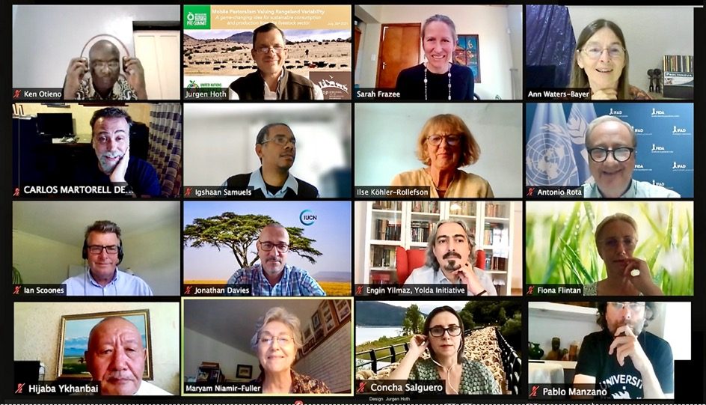

Jürgen Hoth has a BSc in Biology (UNAM, Mx) and an MSc in Rural Development & International Planning (University of Guelph, Canada), with postgraduate training in tropical ecology, behavioural ecology, geography & regional planning. His interest in understanding and addressing natural & social processes related to nature conservation led him to live and work from the rainforests of Panama and Costa Rica to the Norwegian Arctic, for NGOs, federal governments, academic institutions, nomads and indigenous groups. He has designed, promoted and supported national & international responses, including strategies & action plans, aimed at conserving natural grasslands, forests, wildlife and human wellbeing at local, continental and global levels.
http://mx.linkedin.com/pub/jurgen-hoth/36/b1/453
https://www.researchgate.net/profile/Juergen-Hoth-Von-Der-Meden

Antonio Rota is Lead Technical Specialist in livestock & pastoral development in IFAD (International Fund for Agricultural Development). He promotes inter-institutional & cross-regional exchange of knowledge to enhance nutrition- & gender-sensitive, climate-resilient & sustainable smallholder livestock systems. He has 35 years’ experience in this field. Before IFAD, he worked with FAO, NGOs & consulting firms in subsaharan Africa, Asia, Latin America & the Caribbean. He has a degree in animal production sciences from the Faculty of Vet.Med. in Milan and a diploma in tropical animal production & health from the Institute of Tropical Medicine in Antwerp.
How to do: Engaging with pastoralists – a holistic development approach https://www.ifad.org/en/web/knowledge/-/publication/how-to-do-engaging-with-pastoralists-a-holistic-development-approach

Jonathan Davies coordinates the Global Drylands Initiative and is Global Agriculture Programme Lead at IUCN (International Union for Conservation of Nature). He leads IUCN’s work on sustainable land management, rangeland restoration & sustainable pastoralism, and is developing its work programme on sustainable agriculture & conservation. He has extensive experience in landscape management & restoration, communal governance & resource rights, assessing land health, ecosystem service valuation, policy design and mobilising investment for ecosystem rehabilitation. He is IUCN’s representative to the UNCCD. He has a PhD in Agricultural Economics and over 25 years’ experience in sustainable development & conservation, especially in Africa, Asia & Europe.
IUCN Global Drylands Initiative: https://www.iucn.org/theme/ecosystem-management/our-work/global-drylands-initiative

Carlos Martorell has a BSc in biology and a PhD in ecology from Universidad Nacional Autónoma de México, where he is professor for ecology & natural resources. He has published 65 scientific articles in international journals. He specialises in plant ecology in semi-arid and other limiting environments. He studied the population ecology of endangered species in anthropic landscapes. His current interest is in how plants interact with each other and with animals, and how this maintains diversity in natural systems. For 20 years, he has worked in a species-rich grassland that is ideal to put to the test ecological theories on multiple species coexistence.
Plant species richness: https://onlinelibrary.wiley.com/doi/pdf/10.1111/j.1654-1103.2012.01400.x
A diversity world record in a grassland: www.scielo.org.mx/pdf/bs/v95n1/2007-4476-bs-95-01-1.pdf
Tyranny of trees in grassy biomes: https://orbi.uliege.be/bitstream/2268/177699/2/Veldmanetal2015-Science-484-5.pdf

Fiona Flintan is Senior Scientist with ILRI (International Livestock Research Institute) specialised in natural resource management, land governance, pastoralism, gender & conflict issues. Based in Rome, she works closely with IFAD (International Fund for Agricultural Development). She worked many years in Ethiopia & Tanzania and did short-term research elsewhere in Africa and Asia. She raises global awareness on rangelands and advocates for more attention to them, e.g. through preparing for the UN Decade of Ecosystem Restoration 2021-30 and the call for an IYRP and as active participant in the Global Landscapes Forum. For several years, she coordinated the International Land Coalition’s Global Rangelands Initiative.
https://www.ilri.org/people/fiona-flintan
https://www.decadeonrestoration.org/
https://www.globallandscapesforum.org/
https://rangelandsinitiative.org/

Engin Yılmaz is Director of the Yolda Initiative, a nature conservation organisation based in Turkey working at international level and focusing on the value of traditional cultural practices, particularly mobile pastoralism, that benefit biodiversity and contribute to efforts for climate change mitigation & adaptation. He is also Coordinator of the Alliance for Mediterranean Nature and Culture, a group of organisations working together to build awareness of cultural landscapes and advocate for traditional practices such as mobile pastoralism. Engin is a member of the IYRP Global Coordination Group and co-chairs the Regional IYRP Support Group for Europe.
https://yolda.org.tr/
https://www.mednatureculture.org/

Ian Scoones is Professor at the Institute of Development Studies (IDC) at the University of Sussex, UK. He co-directs the Economic & Social Research Council STEPS Centre, leads the PASTRES (Pastoralism, Uncertainty & Resilience) programme supported by a European Research Council Advanced Grant and is member of the editorial collective of the Journal of Peasant Studies. Over 35 years, he has worked on issues of pastoralism in the context of agrarian and environmental change, particularly in eastern and southern Africa.
STEPS Centre: https://steps-centre.org/
PASTRES: https://pastres.org/

Hijaba Ykhanbai is Director of JASIL Environment & Development Association since 2009. Before this, he worked with the Mongolian Ministry of Nature & Environment. He did a PhD on “Economic valuation of forest resources in Mongolia” and a Doctor of Economic Sciences on “Economic incentives & regulatory instruments for forest & pasture management in Mongolia” from Sankt-Peterburg Forestry Academy, Russia. He led a study team on collaborative learning for co-managing natural resources in Mongolia. He authored several books on economics of environment & development and community-based rangeland management. He is focal point of CAPA (Central Asian Pastoral Alliance) and Chair of the Central Asia & Mongolia IYRP Support Group.
JASIL Environment & Development Association www.cbnrm.mn

Ken Otieno is Executive Director of RECONCILE (Resource Conflict Institute), a policy-research, advocacy and capacity-building organisation in Kenya, and Technical Coordinator of the Rangelands Initiative Africa, a Global Programme of the International Land Coalition (ILC). He is also Regional Focal Point for CELEP (Coalition of European Lobbies for Eastern African Pastoralism). He is a social scientist with 15 years’ experience working in national and international organisations.
https://reconcile-ea.org
https://rangelandsinitiative.org
http://www.landcommission.go.ke/article/county-spatial-planning-in-pastoral-areas-annex-to-cspmonitoring-and-oversight-guidelines

Ilse Köhler-Rollefson, a veterinarian by training, has conducted research on pastoralism for over 30 years. She is co-founder of the League for Pastoral Peoples, an international research & advocacy organisation for pastoralists and small-scale livestock keepers. She is based in India, where she co-initiated the country’s first dedicated camel dairy, which encourages the maintenance of the traditional mobile production system. She has published more than 100 scientific papers and several books, including the popular book Camel Karma.
League for Pastoral Peoples: www.pastoralpeoples.org
Pastoralist map: http://www.pastoralpeoples.org/pastoralist-map
http://umap.openstreetmap.fr/de/map/pastoralists_563977#5/27.235/60.315
Camel Charisma: www.camelcharisma.com

Sarah Frazee is a conservationist keenly interested in the role of nature in agriculture. After her Masters at University of Cape Town, she was Director for Conservation International’s programme in South Africa. This became an independent NGO, Conservation South Africa, in 2010 and pioneered initiatives focused on the role of healthy ecosystems in sustainable agriculture and green economic development. In 2016 she set up Meat Naturally, a social enterprise to help small-scale livestock farmers access the formal red-meat market through better environmental management. She is exploring how to replicate this model across Africa. She received SEED, Henry Arnhold Fellow and SAB Foundation Awards for innovation in social enterprise.
Meat Naturally: www.meatnaturallyafrica.com/
Videos on mobile market access:
Mobile auctions: https://youtu.be/kxQbPXltRJM and https://vimeo.com/194947879 password csa
Virtual auction example: https://www.swiftvee.com
Meat Naturally would like to thank Conservation South Africa for use of the above videos. Conservation South Africa is one of Meat Naturally’s clients and the video shows the role Meat Naturally plays provides in terms of livestock production support and market access to incentivize and reward communal livestock farmers for adopting improved land and livestock management.
Mobile abattoir: https://youtu.be/MBDi1QHHFsk
Policy opportunities: https://weekly.regeneration.works/p/carving-up-the-meatpacking-cartel

Pablo Manzano Baena is post-doctoral researcher at the University of Helsinki and associate researcher at the Basque Centre for Climate Change. A rangeland ecologist by background, his transdisciplinary interest on livestock-based socio-ecosystems leads his research to solve knowledge gaps and scientific misconceptions and to explore sustainability pathways. He has experience both in the research and in the international development sectors at the global scale, with field experience on all continents.
Pastoral is significant part of sustainable future: https://www.helsinki.fi/en/news/life-sciences/pastoralism-integral-part-sustainable-future
Climate-friendly meat: https://blogs.helsinki.fi/voices-for-sustainability/climate-friendly-meat-a-nuanced-approach-to-climate-savvy-beef-consumption/

Damdindorj Batmunkh is Director-General of Livestock Policy Implementation and Coordination at the Ministry of Food, Agriculture and Light Industry in Mongolia. He has been with the Ministry for over 25 years, serving as Director in various departments. He completed his PhD in Hydrogeology at the Mongolian Technical University in 2001. He also heads the National Steering Group for the Mongolian call to the United Nations to designate an IYRP in 2026.
www.iyrp.info

Concha Salguero, born in Extremadura (Spain), has a law degree and Masters degrees in International Commerce and International Economic Law. She has worked on environmental law and policies since 1992, first in Spain and later at EU level. In 2004 she became the environmental representative in two EU Commission Advisory Groups. In 2009–12 she worked in the UK for various organisations, including on EU Fisheries Policy reform. She lives in Madrid and is project coordinator for the NGO Trashumancia y Naturaleza (TyN) focused in supporting and promoting pastoralism and transhumant systems as key to maintain environmental, social & economic values.
TyN website: www.trashumanciaynaturaleza.org
TyN is part of Alliance for Mediterranean Nature & Culture: https://www.mednatureculture.org/

Igshaan Samuels is rangeland ecologist with the Agricultural Research Council (ARC) in South Africa. He holds an MSc in botany & ecology from the University of the Western Cape and a PhD in botany from the University of Cape Town. He has about 20 years’ experience in pastoralism, particularly in dryland ecosystems. He is incoming president of the Grassland Society of Southern Africa and member of the coordinating team for the Eastern & Southern Africa Regional IYRP Support Group.
Agricultural Research Council (ARC), South Africa: https://www.arc.agric.za

Maryam Niamir-Fuller is Vice Chair of the International Support Group for the IYRP. She received a PhD in Range Management from the University of Arizona and has numerous peer-reviewed publications on mobile pastoralism and rangelands. She has 35 years’ experience in sustainable development around the globe through her work with USAID, FAO, IFAD, UNDP and UNEP. She helped initiate WAMIP (World Alliance of Mobile Indigenous peoples) and WISP (World Initiative for Sustainable Pastoralism). Now retired, she is on the Board of the journal Nomadic Peoples and the Springer Open Journal Pastoralism.
www.iyrp.info

Ann Waters-Bayer is agricultural sociologist (Dr agr. Hohenheim University) with Agrecol Association, Germany. She retired after 35 years with the Netherlands Royal Tropical Institute and ETC Foundation, the German Institute for Tropical & Subtropical Agriculture and the International Livestock Centre for Africa (ILCA). She supports several networks, including Prolinnova (Promoting local innovation in ecological agriculture), CELEP (Coalition of European Lobbies for Eastern African Pastoralism) and the IYRP Global Coordination Group. She has published on rural innovation, agroecology, pastoralist development, gender issues etc and is Associate Editor of The Rangeland Journal.
www.prolinnova.net
www.celep.info
www.agrecol.de

In order of speaking and inserted in Chat box during the online event on 26 July 2021

