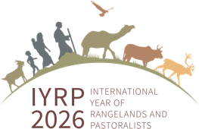

**Co-Chairs of IYRP Global Alliance   
at UNCCD COP 16**

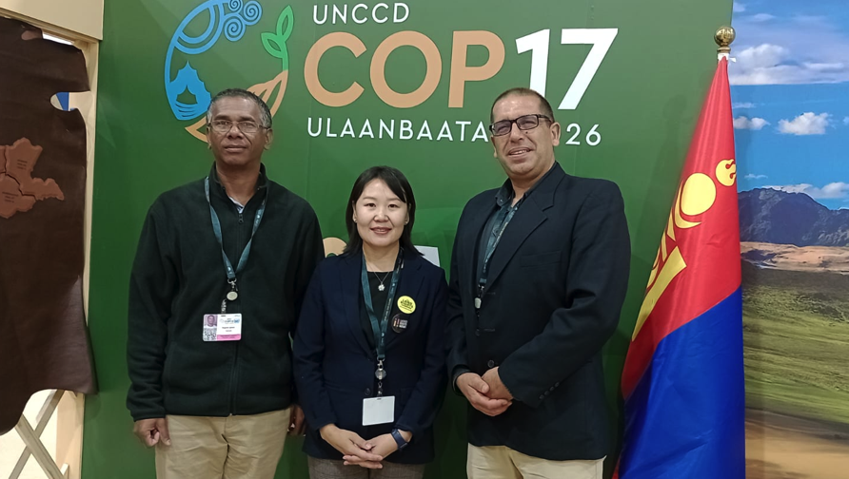

The three co-chairs of the Global Alliance for the International Year of Rangelands & Pastoralists – ***Igshaan Samuels*** (South Africa), ***Burmaa Dashbel*** (Mongolia) and ***Enrique Michaud*** (Peru) – met face-to-face for the first time at the 16th Conference of Parties of the United Nations Convention to Combat Desertification (UNCCD COP16), held in December 2024 in Riyadh, Saudi Arabia. They and several other members of the IYRP Global Alliance are attending the numerous events during the COP that highlight rangelands and pastoralists, such as:

* Mapping grassland and savannah hotspots: bridging knowledge gaps for nature and people
* Women for the future: enabling women-led rangeland restoration and resilience
* Protecting and restoring rangelands
* Restoring the forgotten landscapes: funding grasslands, savannahs and rangelands
* Principles and good practices in sustainable rangeland management for land restoration
* Valuing grasslands: critical ecosystems for nature, climate and people
* Data dilemmas: bridging knowledge gaps for inclusive rangeland governance
* Shared lands, shared futures: inclusive governance for rangelands and pastoralists
* Restoration of global rangelands for people, nature and human wellbeing and development
* Mobility matters: in the footsteps of pastoralists and hunter-gatherers walking around the world
* Restoring balance: livestock management for ecosystem resilience & Land Degradation Neutrality (LDN)
* Scaling up sustainable land management for LDN in South Africa's grazing lands
* Breaking barriers: finance, science and partnerships for rangeland restoration
* Accelerating actions for healthy land in East Africa: pathways to pastoralist prosperity, resilience and food security
* Sustainable investments for large-scale rangeland restoration.

One side event is focused on the IYRP: [Road to the IYRP2026](https://www.iyrp.info/sites/iyrp.org/files/IYRP%20at%20UNCCD%20COP16_0.pdf).

During the COP, the IYRP Global Alliance is sharing some publications of its Working Groups:

* Policy brief “[Global action for sustainable rangelands and pastoralism to achieve LDN](https://iyrp.info/sites/iyrp.org/files/IYRP_LDN_Policy_Brief%20low-res.pdf)”
* Summary brief “[Building on the knowledge and initiatives of pastoralist women](https://www.iyrp.info/sites/iyrp.org/files/2024%2011%20iyrp%20brief%20summary%20pastoralist%20women.pdf)”
* Position paper “[Pastoralism and protected areas](https://www.iyrp.info/sites/iyrp.org/files/IYRP%20position%20paper%20Pastoralism%20%2B%20protected%20areas%20Dec%202024.pdf)”.