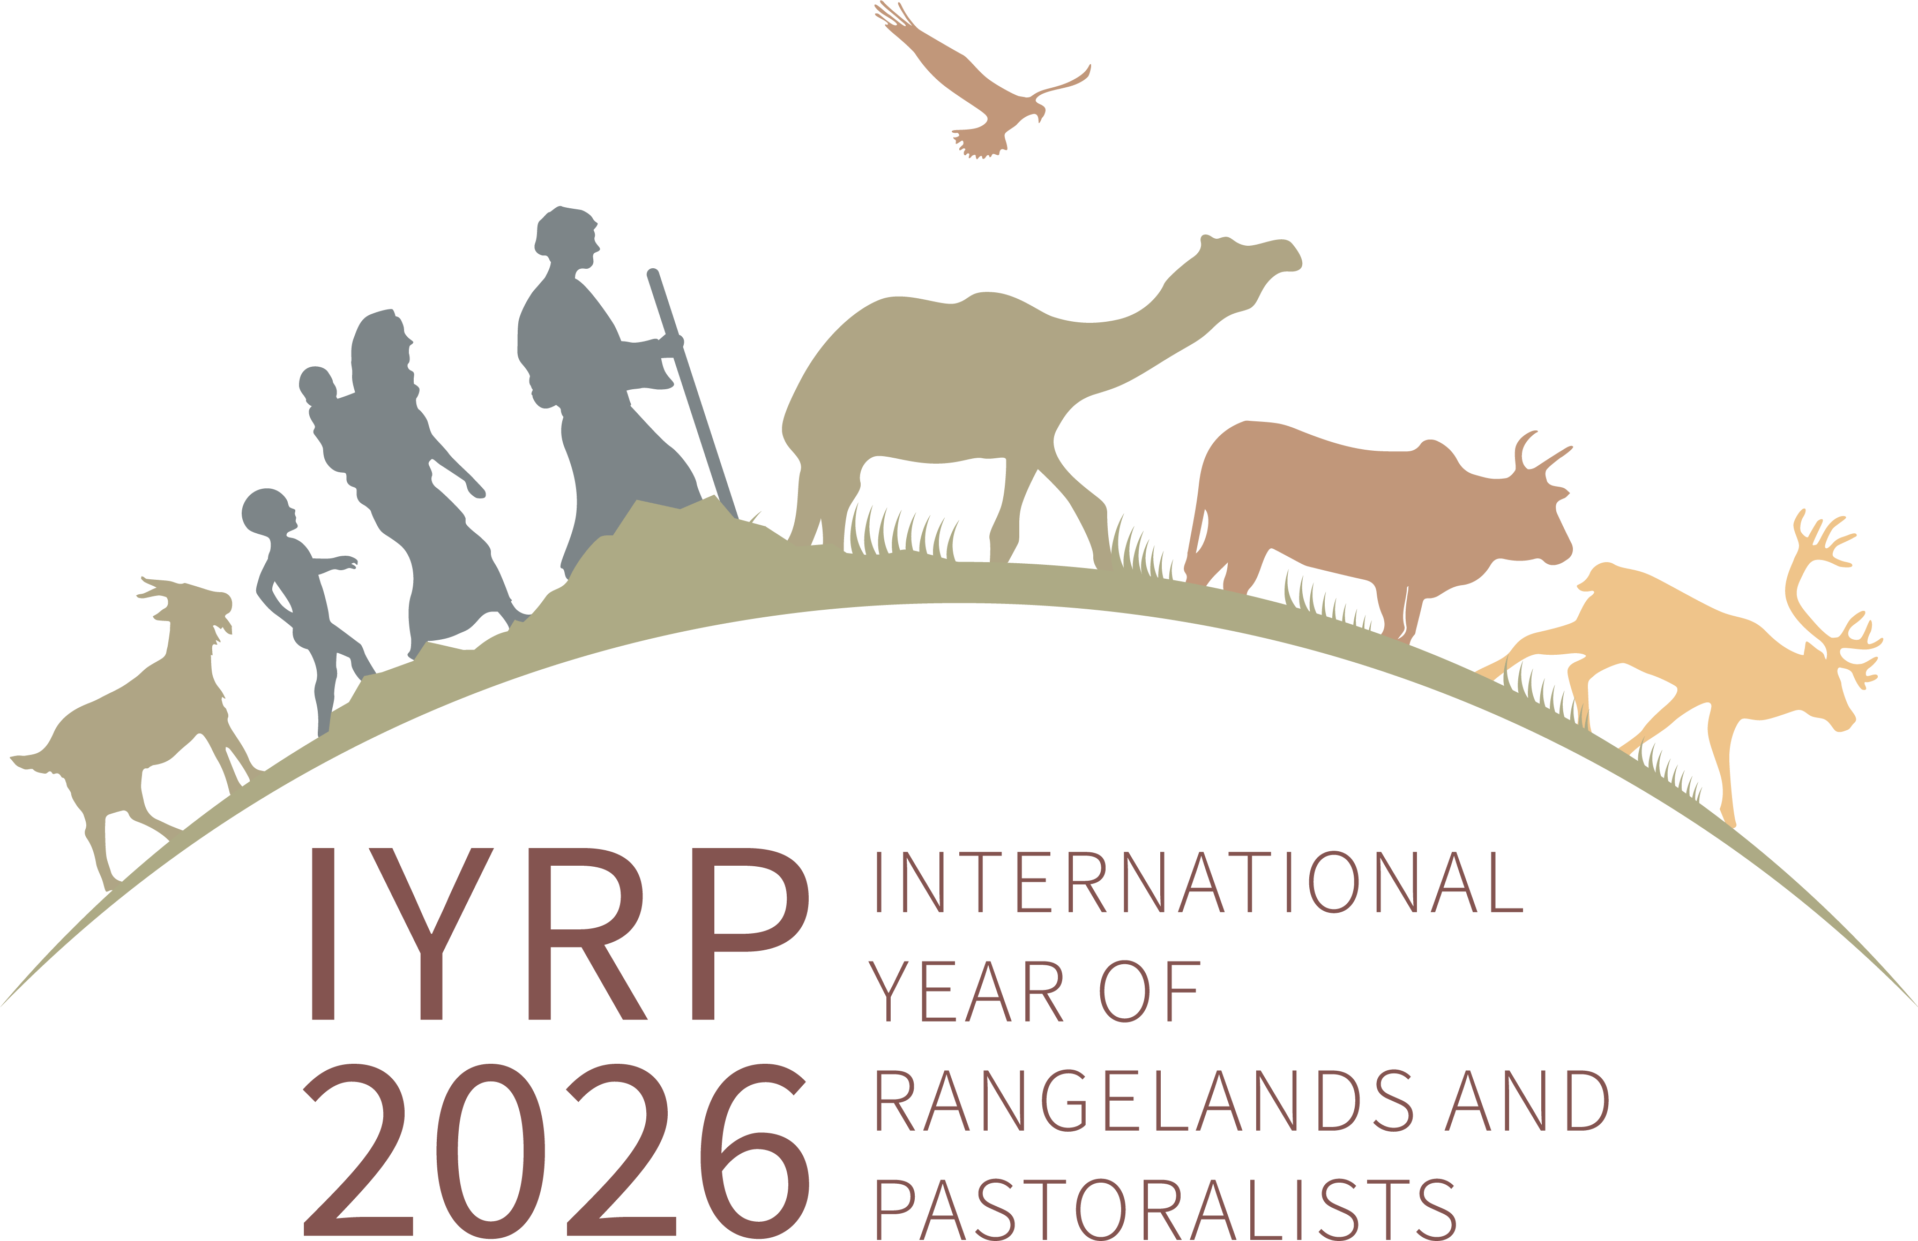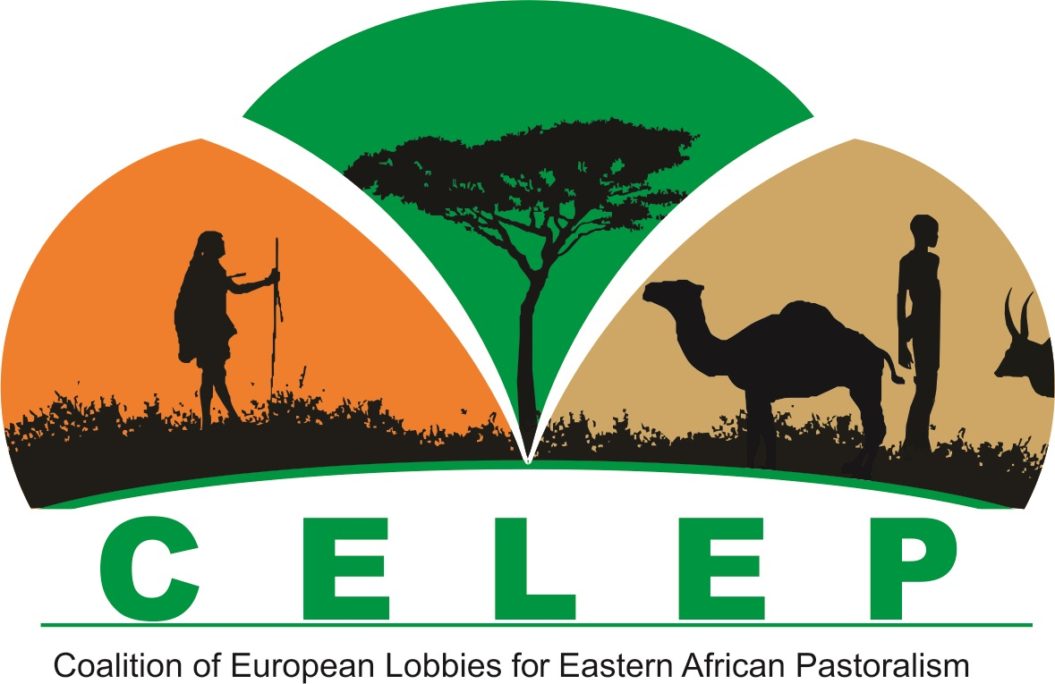

IYRP/CELEP co-organise pastoralism session at COP27 Climate Change
SNV (Netherlands) was the lead organisation in convening a session on “Pastoralism and rangelands restoration: promising solutions to benefit our planet and people” on 12 November 2022 in the Food Systems Pavilion at COP27 of the UN Framework Convention on Climate Change (UNFCCC). Co-organisers were the Environmental Defense Fund (EDF), the International Year of Rangelands & Pastoralists Global Coordinating Group (IYRP-GCG) and CELEP (Coalition of European Lobbies for Eastern African Pastoralism) through Agrecol Association Germany.
Maryam Niamir-Fuller, co-chair of the IYRP GCG, gave a keynote speech in this session. The text of her presentation can be found here. A video recording of all sessions on 12 November (SCALE Day) in the Food Systems Pavilion, including the session on pastoralism, can be found here.

