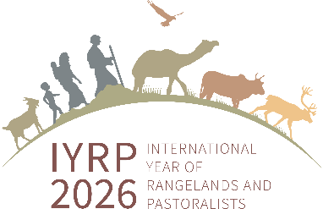

"CAMEL HERITAGE FESTIVAL - 2023" ,HULD SOUM, DUNDGOBI AIMAG,MONGOLIA

The core of the world's Bactrian camel (Camelus bactrianus) ( https://en.wikipedia.org/wiki/Bactrian_camel) is found in Mongolia. As a result of a certain measures taken by the government jointly with the local administrative, scientists and herders to protect the gene pool of camels, improve their quality, and increase its population, "Khanyn Khetsi Brown", "Galba Gobi Red" and "Tukhum Tungalag Brown" f approved as breeds in 2015-2016 , "Lamyn Geegenii Red" and "Oldokhyn Brown Camels" which are bred for meat and wool were approved as varieties in 2020.
Historically, Mongolia counted 895,300 camels In 1954, which was the largest number, and in 2002, during the transition to a market economy, it counted 253,000. The government and local authorities /communities are taking a lot of activities and actions to increase the camel population, improve their quality, and maximize its benefits. As a result of these measures, the number of camels has been increasing year after year as reaching 470.4 thousand by the end of 2022, after 20 years since 2002.
The Office of the Governor of Dundgobi aimag and Khuld soum, in cooperation with local herder’s communities and national stakeholders , organized the "Camel Heritage Festival - 2023" on 26 Jan., 2023, in Khuld soum of Dundgobi aimag, Mongolia.
"Camel Heritage - 2023" was one of the first events that are being conducted /cooperated by "Central Asia and Mongolia" Regional International support group, RISG for IYRP , y with the Mongolian Ministry of Food, Agriculture and Light Industry ,MoFALI, and with local governments and Pastoralist communities for maintaining sustainable use and protection of Rangelands, increase the income of Pastoralists and to promote the heritage and culture of pastoralists.
The event included a wide range of participants including Ms. Munkhtsetseg, Member of Parliament, Mr. Ankhbayar, Deputy Governor of Dundgobi aimag, Mr. Byambalkhagva, Governor of Khuld Soum, Mr. Byambadorj, Senior Specialist of Animal Husbandry Policy Implementation Department of the MoFALI ( https://www.mofa.gov.mn/home ) , Dr. Ykhanbai Hijaba, Co-chair of the "Central Asia and Mongolia" International Support Group, RISG, for the International Year of Rangelands and Pastoralists (IYRP), and Director of Environment and Development Association JASIL http://www.cbnrm.mn/contact.html , Ms. Shine-Uyanga, Head of the Administration Office, the Food and Agriculture Department of Dundgobi aimag, Ms. Horloo S.., Leader of “Gobi Mirage” Cooperative of pastoralists, Mr. Enkhbat, Project consultant of “The Livestock Commercialization Project for Mongolia” by the World Bank, Dr. Thomas, Researcher of the University of Cambridge, journalists of “Malshin TV” , and totally more than 100 camel drivers from herder’s communities of Dungobi and Umnugobi aimags of Mongolia.
Within the framework of the "Camel Heritage Festival - 2023" , a variety of competitions such as a race for young and mature camels; a short-distance relay race for mature camels; carving silver pegs and spinning camel halters; as well as a beauty contest among the herders and camels. Also, the best camel dairy products, as Camel milk (Khoormog) was also prized. The next year’s "Camel Heritage Festival “will be organized in Ulziit Soum of Dundgobi aimag.
Challenges:
- Camel Festival promoted cultural identity of Gobi camel herders, and provide wide range of exchange opportunity among the herders, local communities and local administrations,
- Dispute the freezing cold climate (around -18-28C) community herders actively participated in all competitions and their camels brought a lot happiness during the whole day of Festival, which means of high-level adaption of local people to climatic extreme conditions,
- The event encourages camel herders, who are located more remote rangelands and traveling in longer distance than other types of animal herding, as well as communities for improving camel breeds, herding and maintaining camels, a more livelihood products, such as Camel milk, which is very important for the COVID pandemic
- Organizing of such events can benefit to camel herders/pastoralists to exchange their experiences, from other side the government and other stakeholders more recognize the importance of pastoralists and rangelands, therefore it can be supported by national, regional and global IYRP campaign.

Blog post written by Dr.Hijaba Ykhanbai, Co-chair of “Central Asia & Mongolia” RISG for IYRP , and
Mr. N.Byambadorj, Senior specialist , Ministry of Food, Agriculture and Light Industry, Mongolia

Feb., 2023, Ulaanbaatar, Mongolia

Photos

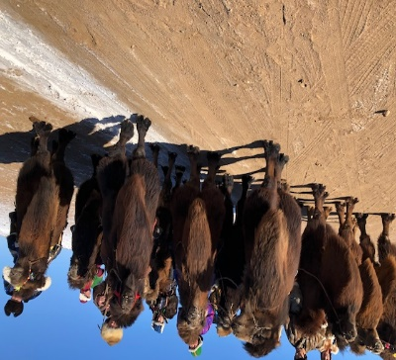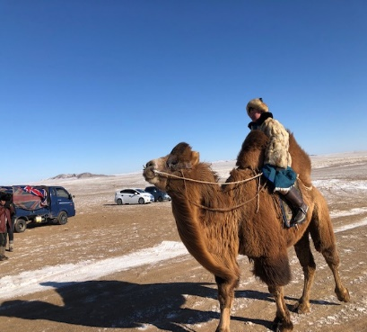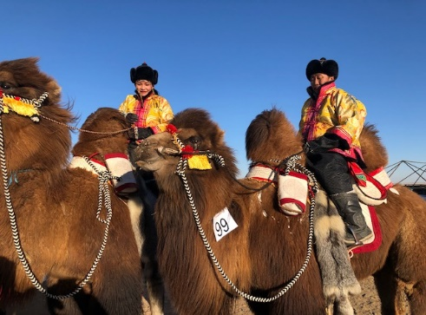
Pic.1-3 Camels and pastoralists ready for the competition; Camel winner; camel herder couple beauty contest

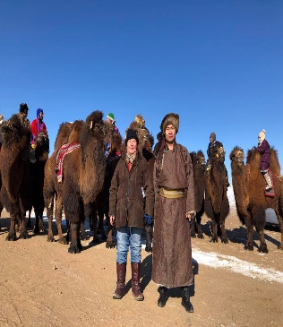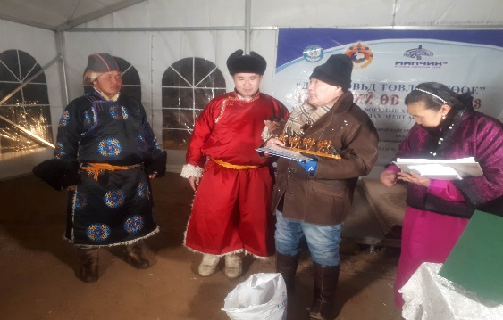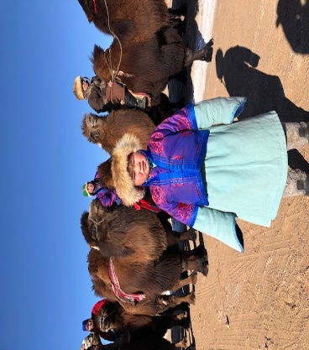
Pic.4-6 Participants from MoFALI Mr.Byambadorj N. and from JASIL Dr.Hijaba Y.; Prize of JASIL to Mr.Oshir, member of Arbijakh community issued by Dr.Hijaba Y., in the closing ceremony with Governor of Khuld Soum, Mr. Byambadorj and Ms. Horloo S.., Leader of Gobi Mirage Cooperative; The future of camel pastoralists

Notes: 1. The Government of Mongolia in cooperation with many other countries and international and national organizations has proposed to establish the “International Year of Rangelands and Pastoralists, 2026” https://iyrp.info/central-asia-mongolia. As a result, on 15 March 2022, during its 76th session, the UN General Assembly unanimously adopted a resolution entitled “International Year of Rangelands and Pastoralists, 2026”.
2. Within the framework of the "Camel Heritage Festival - 2023" , a variety of competitions such as a race for young and mature camels, a short-distance relay race for mature camels, carving silver pegs and spinning camel halters, as well as a beauty contest among lactating, and best camel dairy products, such as Camel milk (Khoormog).
3. Live broadcasting of the Festival activities on the social media can be seen here https://www.facebook.com/hijaba.ykhanbai/posts/pfbid02gxeS677CSvSbkHyPztqUWNZSXE28XET3NTHZpTFcbWCw8RVsnDQPLB55NH1jehWyl
4. “Aimag” is province, and “Soum” is district in Mongolian territorial administration structure.

