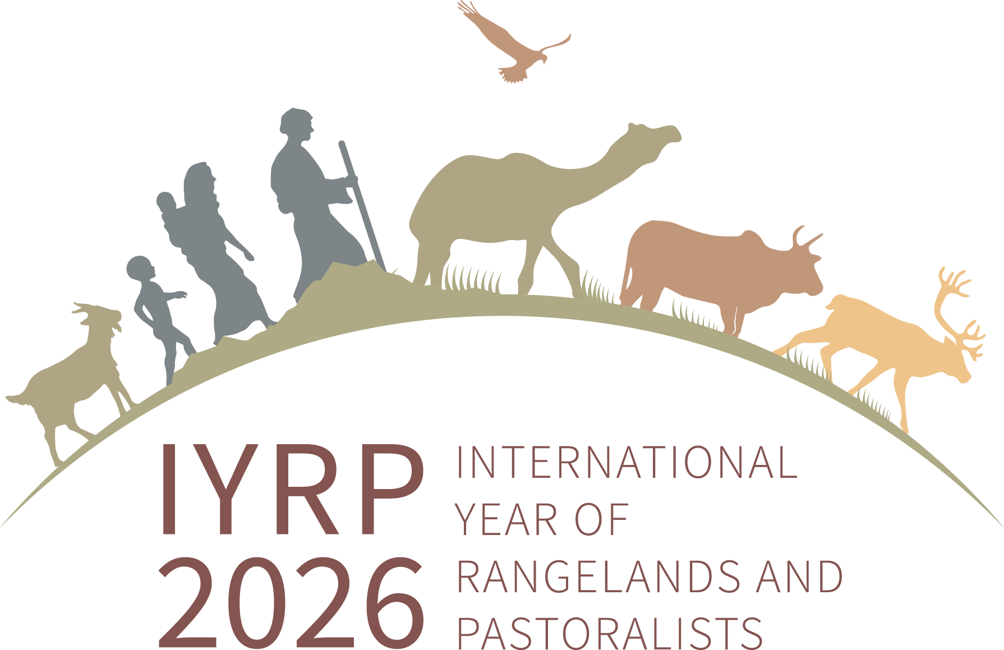
Regional IYRP Support Group (RISG) and global co-chairs and email addresses
(as of 1 June 2024)

Co-chairs /facilitators of the RISGs
Arctic: Anders Oskal (oskal@reindeercentre.org), (Ms) Ellen-Sara Sparrok Lasen (ellensara_sparrok@hotmail.com) & (Ms) Sara-Elvira Kuhmunen (saraelvira.kuhmunen@gmail.com)
Australasia: (Ms) Dana Kelly (danammkelly@gmail.com)
Central Asia & Mongolia: Hijaba Ykhanbai (y.hijaba@gmail.com) & Hasrat Arjjumend (harjjumend@gmail.com)
East Asia: Ruijun Long (longrj@lzu.edu.cn), Han Guodong (nmghanguodong@163.com) & (Ms) Rong Yuping (rongyuping@cau.edu.cn)
Eastern & Southern Africa: (Ms) Andiswa Finca (fincaa@arc.agric.za), Ken Otieno (kenotieno@reconcile-ea.org), Loupa Pius (daahman89@gmail.com) & (Ms) Prisca Mugabe (phmugabe@gmail.com)
Europe: (Ms) Francesca Pasetti (fpasettib@gmail.com), (Ms) Zuriñe Alba Iglesias González (vincapervincalila@gmail.com) & Joseph Boussion (joseph.boussion@gmail.com)
Middle East & North Africa: Hossein Badripour (badripour@yahoo.com)
North America: Barry Irving (birving@ualberta.ca), David Borre (davborre@gmail.com) & Layne Coppock (layne.coppock@usu.edu)
South America & Caribbean: Pablo Frere (pablofrere@gmail.com), Pablo Manzano Baena (pablo.manzano.baena@gmail.com) & (Ms) Cecilia Turin (ceciturin@gmail.com)
South Asia: Perumal Vivekanandan (vivekseva@gmail.com), (Ms) Rashmi Singh (rashmi89singh@gmail.com) & (Ms) Bhavna Desai (bhavanarabari@gmail.com)
West & Central Africa: Harouna Abarchi (ab.harou@gmail.com) & (Ms) Serena Ferrari (serena.ferrari@cirad.fr)

Co-chairs of the International Support Group for the IYRP coalition
(Ms) Burmaa Dashbel (d.burmaa.1@gmail.com)
Enrique Michaud (enrique.michaud@gmail.com)
Igshaan Samuels (isamuels@uwc.ac.za)

