Webinar on pastoralism & water
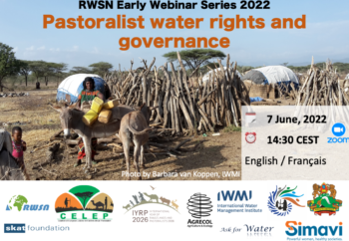
The Rural Water Supply Network (RWSN), CELEP (through Agrecol Association, Germany), IWMI (International Water Management Institute), SIMAVI Foundation (Netherlands) and Skat Foundation (Switzerland) co-organised the 4th webinar of the RWSN Early Webinar Series 2022 entitled: “Pastoralist water rights and governance” on 7 June 2022.
Water supply projects often overlook or misunderstand mobile pastoralists’ water needs and management practices. Speakers from Africa and Asia shed light on pastoralists’ water tenure, rights and governance, with particular attention to the issues of pastoralist women. This webinar was a contribution to building momentum and filling knowledge gaps in the lead-up to the United Nations International Year of Rangelands & Pastoralists (IYRP) in 2026.
The speakers were:
- Maryam Niamir-Fuller, Co-Chair, IYRP Global Coordination Group: Introduction to pastoralism & the IYRP
- Oliver Wasonga, University of Nairobi, Kenya: Pastoralists & seasonality in water management in East Africa
- Neeta Pandya, Pastoralist Women Alliance, India: Pastoralist women’s perspectives & water governance in India
- Astou Diao Camara, Bureau of Macroeconomic Analysis, Senegalese Institute of Agricultural Research: Pastoralism & access to water resources targeted by agribusiness: case of north Senegal
- Michael Odhiambo, People, Land & Rural Development, Kenya: discussant
- Adrian Cullis, Coalition of European Lobbies for Eastern African Pastoralism (CELEP): Closing remarks
The recording of the webinar is available on vimeo: https://vimeo.com/718011011
Individual video presentations can be found here: https://www.youtube.com/channel/UC_HF52TbX73xANXQ_ezXrEg
All the presentations are also available as PDFs in English and French here: https://www.rural-water-supply.net/en/resources/details/1062

